The

Cunnius

Family

John Jacob Cunnius

1700 - ?

Johannes “John” Cunnius

1733 – 1808

Johannes Jacob Cunnius

1765 –1863

Tarlton Cunnius

1801 – 1870

Nancy Ann Cunnius

1825 – after 1910

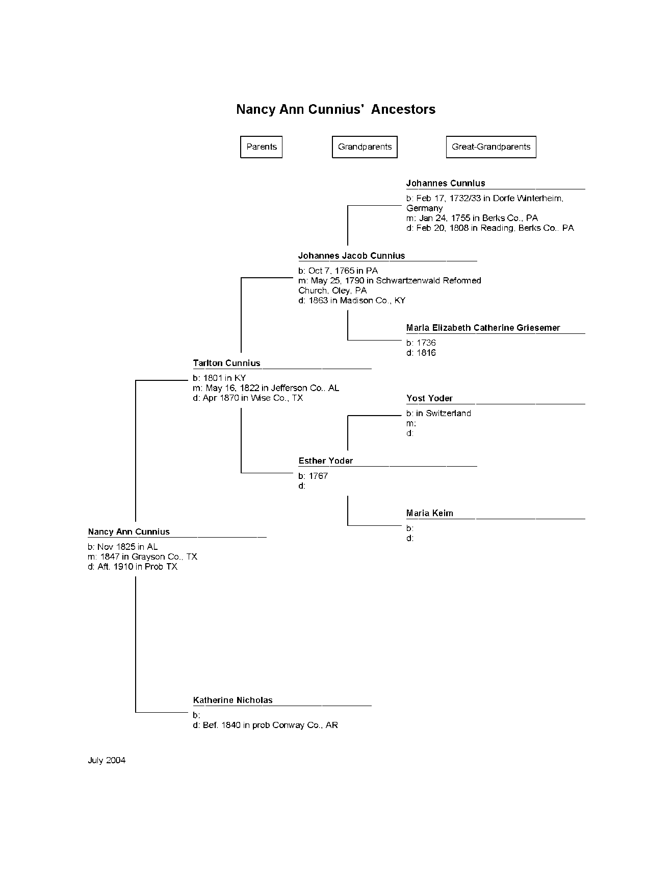

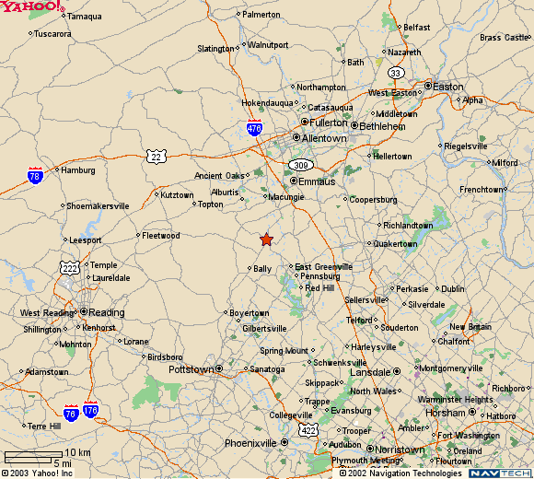
Reading, PA
Hereford, PA

John Jacob Cunnius
1700 - ?

John Jacob Cunnius left Germany in 1749 on the ship Leslie, arriving in the port of Philadelphia, PA. He settled his family in Hereford Township, Berks Township, PA.

Very little is known about this man and his generation.

Johannes (John) Cunnius
1733 – 1808

Johannes (John) Cunnius was born in Dorfe, Winterheim, Germany 1733, and the son of John Jacob Cunnius. John was 16 years old when he came into the United States, having traveled from Germany with his family, arriving in Philadelphia aboard the ship Leslie in 1749. The Cunnius family settled in Hereford Township, Berks Co., Pennsylvania.

John Cunnius is listed as early as 1767 as a joiner [carpenter] in Hereford Township and as late as 1790 in the same location. He was first noted in Reading Pennsylvania in 1792 while completing work on the Trinity Lutheran Church there.

While he was living in Hereford Township, Berks Co., PA he married Maria Elizabeth Catherine Griessmer on January 24, 1755. Maria was born in 1736 and her father was Valentine Griessmer, also of Hereford Township. Her mother’s name is unknown. She died in Berks County in 1816.

John was a member of the Revolutionary Army, as evidenced by two settlement records listing him as a member of the 20th Pennsylvania Regiment. On one report, dated Aug 2, 1784, it indicates he received $20 as a gratuity allowed by Congress to non-commissioned officers and privates who served during the Revolutionary War. This is certificate number 73480.

A second document also dated Aug 2, 1784, indicates he received $102 as his pay from Jan 1, 1783 to Nov 3, 1783. This is certificate number 73122.

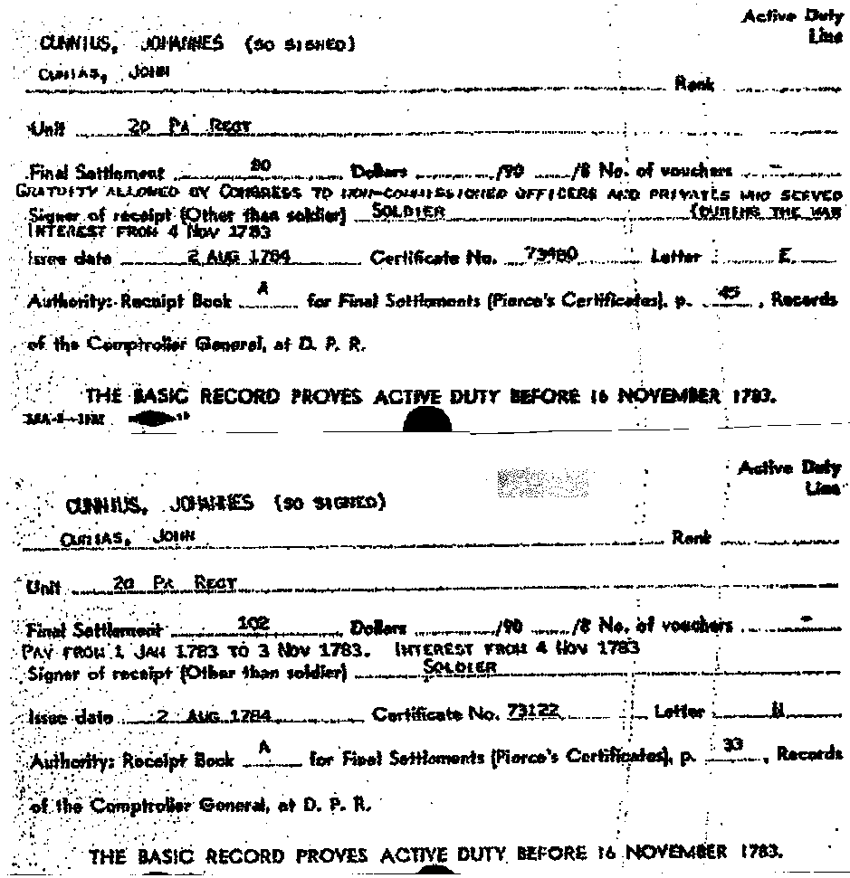

John was well known as a master wood carver and craftsman. His building accomplishments are well documented, and include; Faulkner Swamp Reformed Church, Gilbertsville, PA (1790); Trinity Lutheran Church, Reading, PA (1791-1793), and St. Stephan's Reformed Church, New Holland, PA (1799-1801), to name a few.

He was also a clock-case carver, and it was his practice to carve his intertwined initials "JC" on his work. His initials can also be found on the buildings he constructed, usually on the front façade.

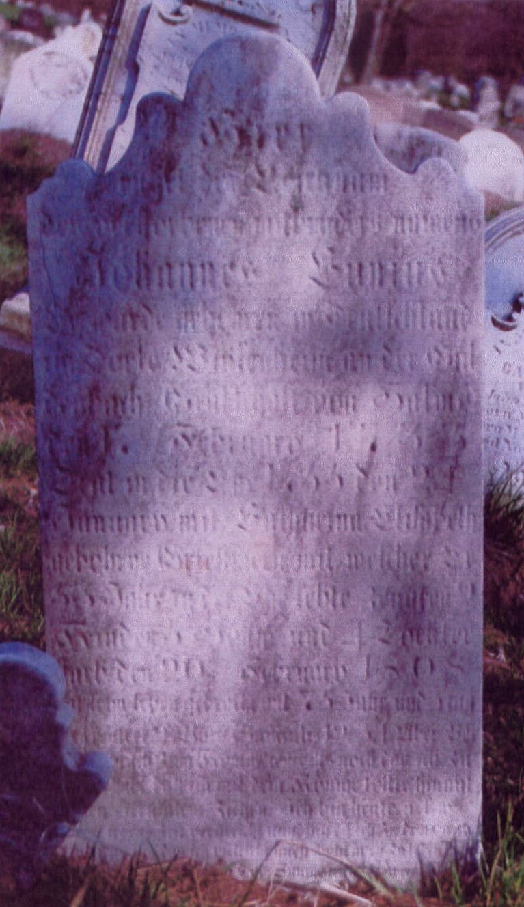

Headstone of Johannes Cunnius
Aulenbach Cemetery, Perkiomen St., Reading, Berks Co., PA

Headstone inscription on Johannes Cunnius’ stone (written in German)

"Hier ruhet der Leichnam/des verstorbernen mit bruders namen/Johannes Cunnius/Er worde geboren im Beutschland/in Dorfe Winterheim an der Gil/denbach Graftschaftvon Salmo/den 7 February 1733/Trat indie ehe 1755 den 24 ten/January mit Catharina Elizabeth/geborne Griessmer mit welcher er/53 jahr in der ehe lebt zeugten 9/kinder 5 sohns und 4 tochter/Starb den 20 ten February 1808/hatseyn

Leben gebracht suf 75 jahr und 3 tag.

Vereheirlebt Buch Samuelen 19 34/ Aber Borsillin sprach zum Konige/ was ists nech des ich zu leben babe dass/ ziebren. Ich bin heute----- meinelebers/zeit verstreicht stundlich eil ich zei dem/Grabe und was ists dae ich veleicht/auch wohl noch zu anen babe.

Seube/meus d-- an demer.Tod. Saurne nicht demn/einst ist noth./ Hier ruhet/Esther/tochter von Johannes Y./u.Catharina Cunnius/wurde geboren den 30 October 1817 gestorben/den 5 August 1819/alt 1 jahr 9 m.5 t./"

English translation …

"Here rests the body of the deceased with brother name Johannes Cunnius. He was born in Germany in the village Winterheim on the Guldenbach, County of Salmo, on the 7th of February, 1733. He married on January 24th, 1755 with Catharina Elisabeth, born Griessmer and with whom he has lived in marriage for 53 years, fathered 9 children, 5 sons and 4 daughters, died on February 20th, 1808.

Has lived 75 years and 3 days.

Book of Samuel 19:34: “And Barzillai said unto the king. How long have I to live, that I should go up with the king to Jerusalem.”

Here rests Esther, daughter of Johannes and Catharina Cunnius, born 30th October 1817, died 5th August 1819, 1 year 9m 5 d old"

Clock works by Daniel Rose
Cabinet by John Cunnius
Located in Winterthur Museum
Wilmington, Delaware

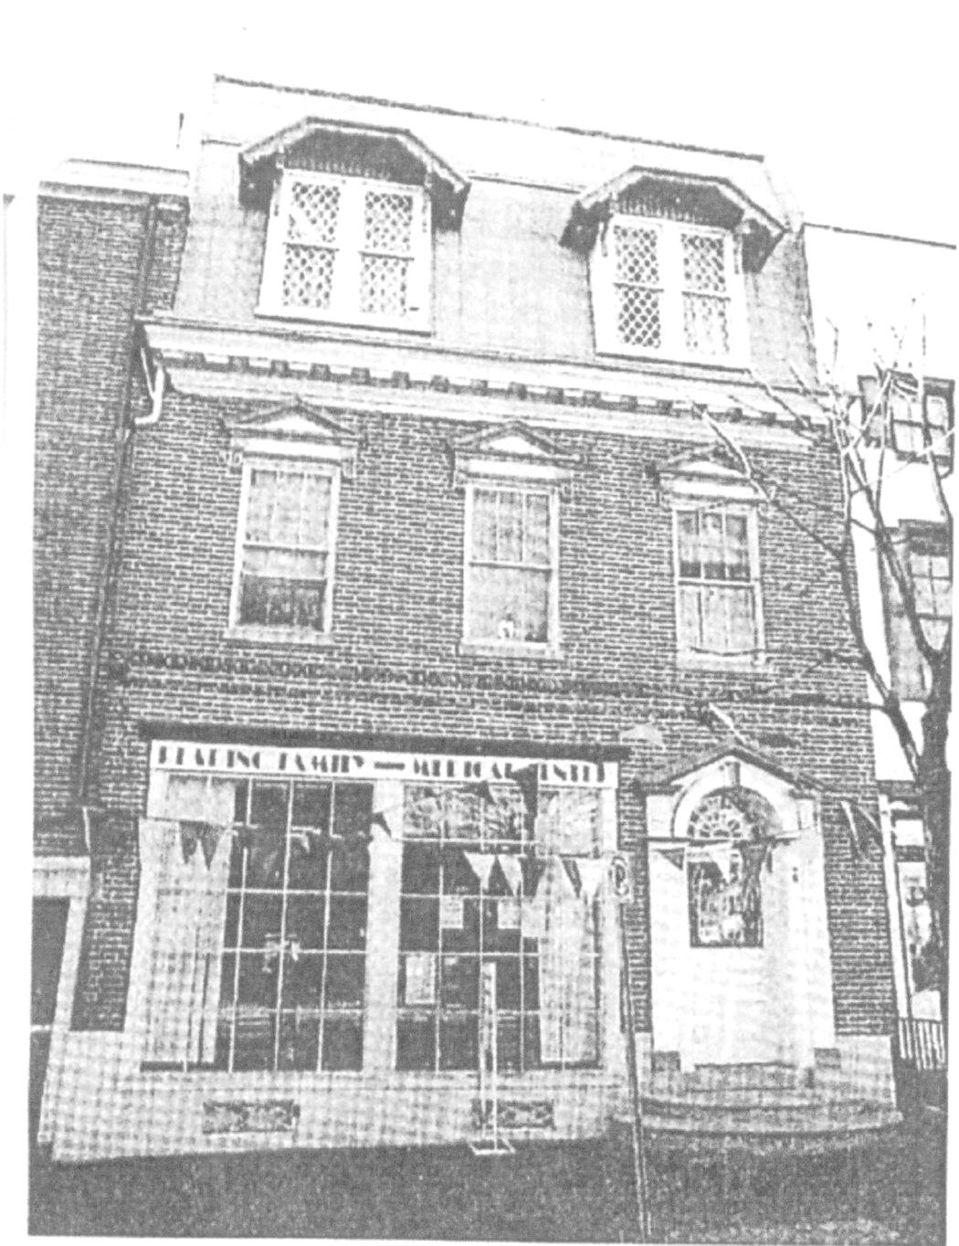

The Daniel Oyster home, located at
40 S. 5th St., Reading, Pa
Built by John Cunnius

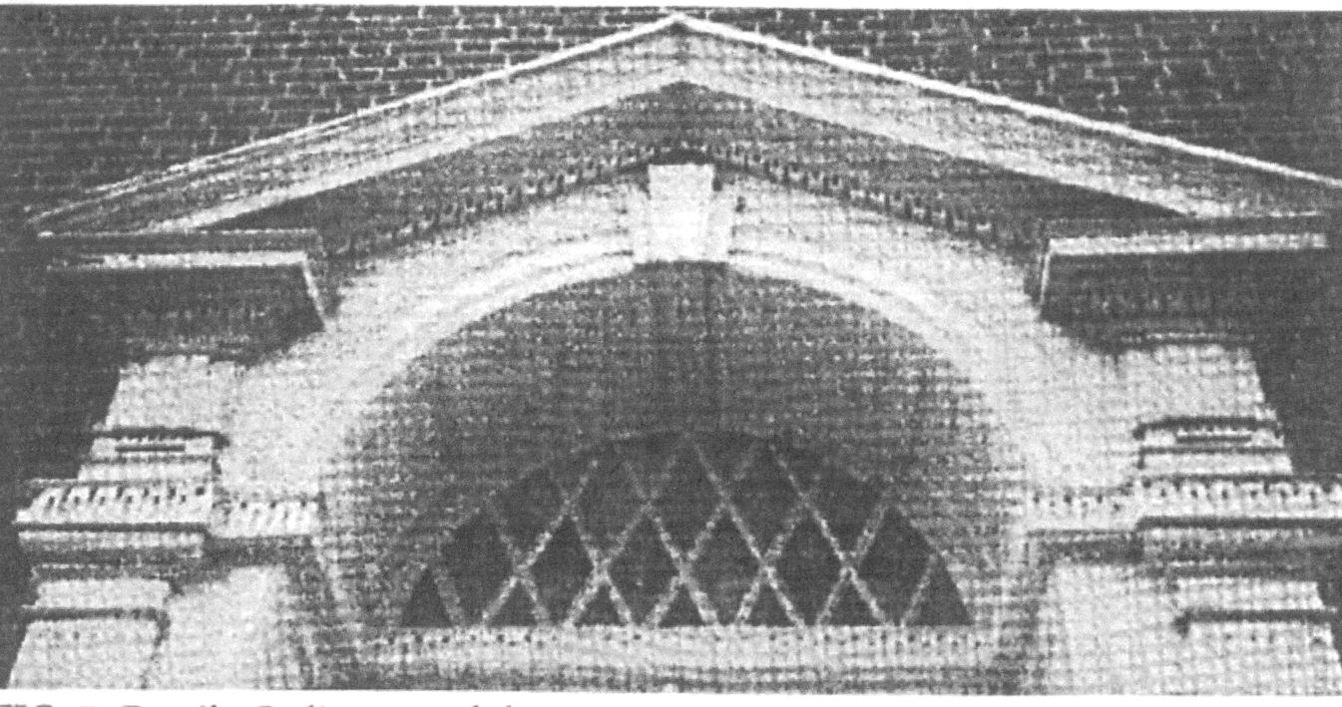

Pediment and door surround, east façade,
Trinity Lutheran Church ,Reading, PA

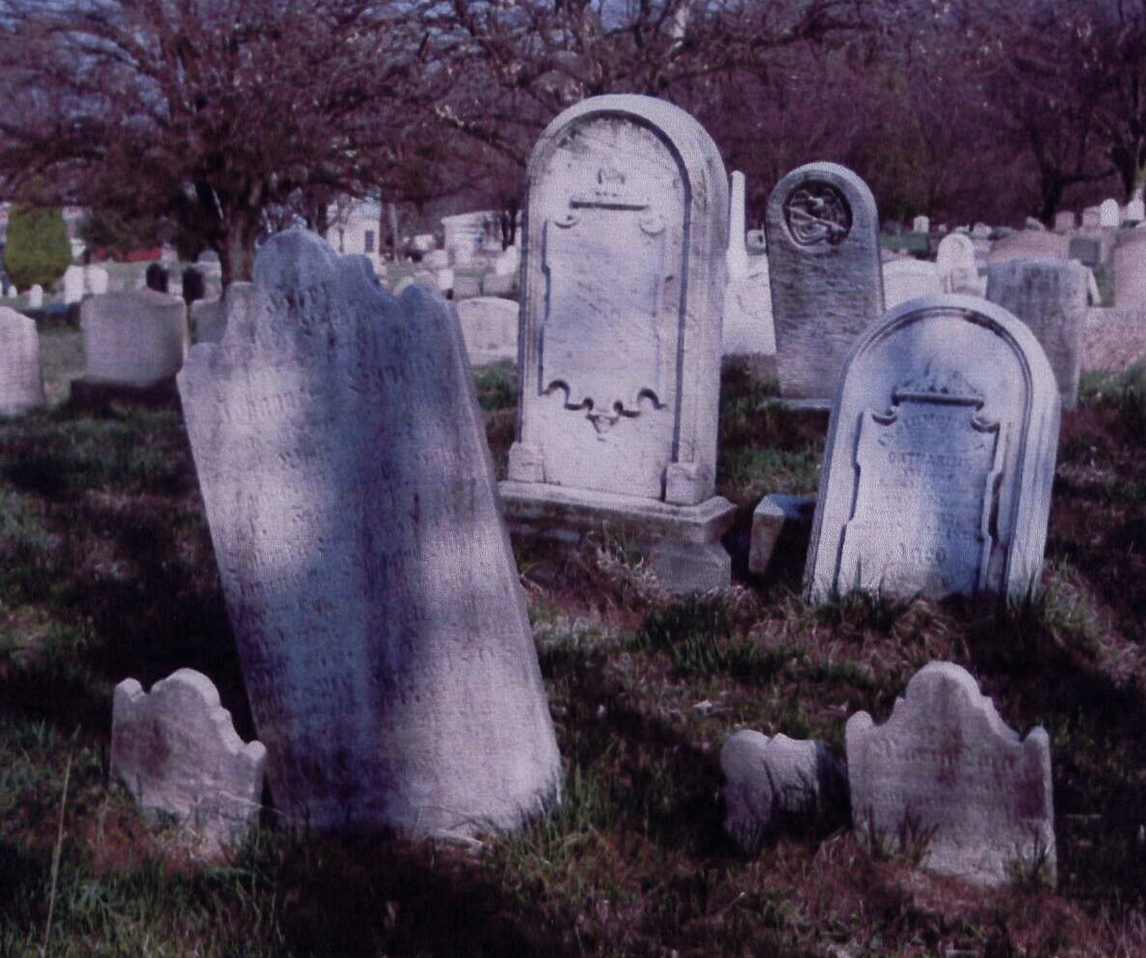

Cunnius family plot
Aulenbach Cemetery, Perkiomen St., Reading, Berks Co., PA
Johannes Jacob Cunnius
1765 – 1863

Johannes Jacob Cunnius was born October 7, 1765 in Berks Co, Pennsylvania. He married first Esther Yoder on May 25, 1790 in the Schwartzenwald Reformed Church, Oley, PA. He would later relocate to Madison County, Kentucky. Upon the death of his first wife, Ester, he remarried Mary Phelps in about 1808, probably in Kentucky.

On the morning of the death of his first wife, he was said to have made the comment to a neighbor, “well, the old devil is dead.” He lived near a body of water on the creek that is still called The Cunius Hole in Madison County, KY.

He wrote his will on October 17, 1840 and it was probated on January 13, 1863 and lists his second wife and their children.

Tarlton Cunnius
1801 – 1870

Tarlton Cunnius was born in 1801 in Madison Co., Kentucky, the son of Johannes Jacob & Ester Yoder. He married Katherine Nicholas on May 16, 1822 in Jefferson County, Alabama. He and Katherine would have six children before she died in about 1842.

In 1840 Tarlton and his ever increasing family were found living in Conway County, Arkansas. They are living in Welborn Township, and he is shown in the Federal Land Records of 1846 as the buyer of 80 acres of land in Conway County, Arkansas. This is recorded in document #4239.

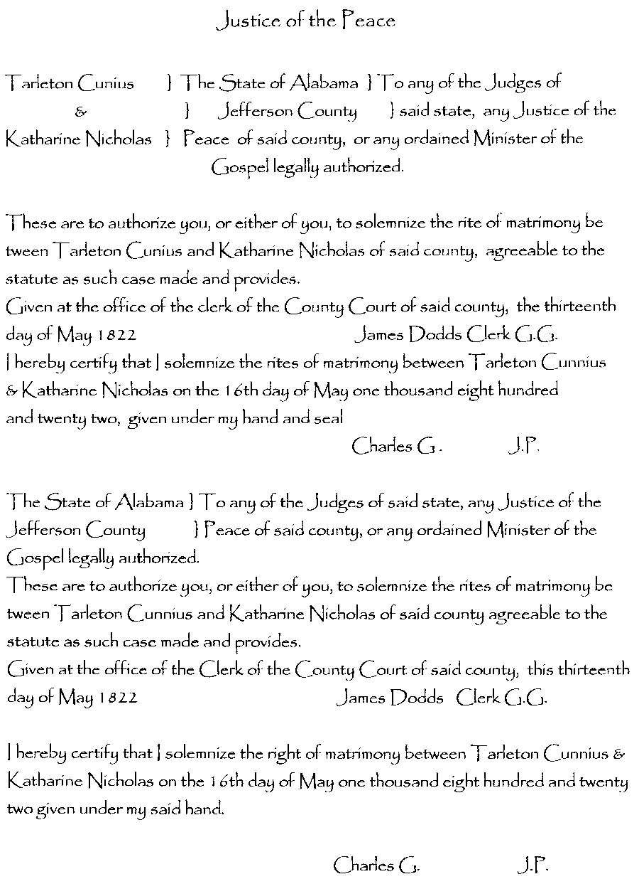
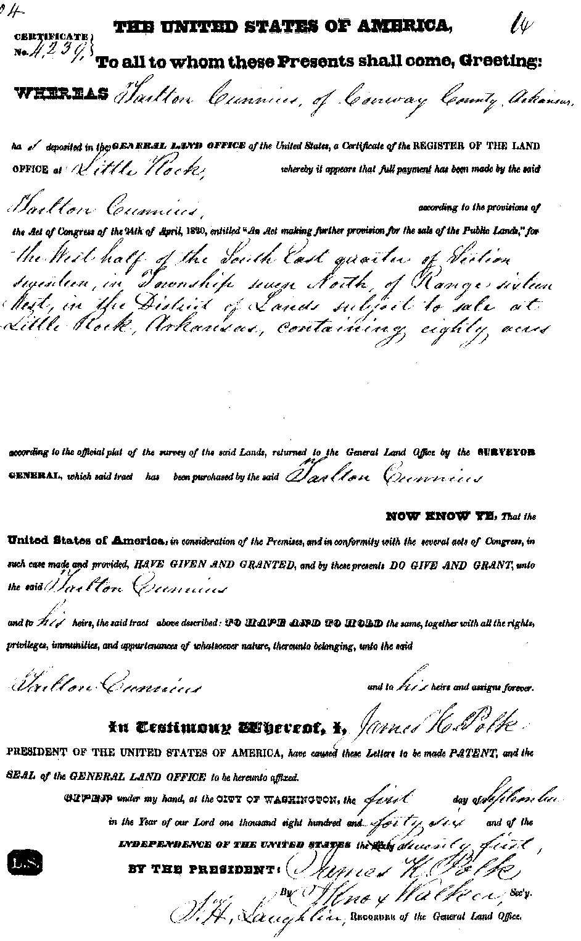
In about 1841 Tarlton and family relocated to (McKinney) Collin County, Texas as a participant in a land grant settlement known as the Peterson Colonies. In Collin County, Tarlton helped organize the Sway Back Methodist Church.

In the book, A History of Collin County, Texas there is this entry: “Rev. John Nobel, Rev. John Cullwell, Rev. Jeremiah Horn, and Rev Tarleton Cunius organized the Sway Back Methodist Church, one and a half miles south of present day Walnut Grove in 1848. All four of them preached there, as did Rev. Jeremiah Martin. Their building was also used as a schoolhouse.”

In about 1846 Tarlton marries Livinia (last name unknown) in Collin Co., TX, and they would have seven children.

In 1858 there appeared an article in the Collin Chronicles (Vol 8, Page 86) written by Elder RC Horn where he talks about his father (RC) buying land in 1858 from John Henry, which was bought from Wm Rice and a portion by Tarleton Cunius. He goes on to say that Tarleton Cunius (Tarlton and Cunnius are spelled several different ways) was a stock man who desired more range for his herds. In 1858 Tarlton sold his home to Maj. Green W. Kerr and moved to Wise County, Texas in 1859. There is the following article in the book: Buckner, Collin County – Genealogy Friends of Plano Libraries:

Buckner, the original county seat of Collin County was three miles northwest of the site of present day McKinney, Texas. Settlement began in the early 1840s when John McGarrah arrived from Arkansas to claim a headright of 640 acres. McGarrah opened a trading post to serve the growing number of settlers who began to arrive in the area in the mid-1840s and donated fifty acres of land for a town site. Later Tarlton Cunius opened a blacksmith shop near the store under a shed made of tree limbs. For almost five years, Buckner was the only place within forty miles where any kind of merchandise could be bought.

Tarlton’s son, Benjamin “Frank” Cunnius was killed by Indians on their last raid into Wise County. These were probably Comanche Indians who were on the rampage in this part of Texas at that time.

The following is an article that appeared in "Pioneer History of Wise County" by Cliff D. Cates, compiled under the auspices of the Wise County Old Settlers' Association - 1907.

+++++BRAVE FIGHT OF FRANK COONIS++++++++++

(this incident occurred in ca 1870, perhaps a little prior to 1870, because Benjamin Frank Cunnius is not in the 1870 Wise Co., TX census, and his widow, Ellen is listed along with a child, Louisa age 1. Also living in their residence is a person named; William Cunnius, age 17, who is black.

One day during the period when the Indians had been very active, Frank Coonis left his father-in-law's home near Greenwood, and started to Hickory Plains, where he had been informed a white citizen had recaptured some stolen horses from the Indians.

Coonis and his father-in-law had lost some horses the day before and he made the trip to Hickory Plains, thinking possibly some of the recaptured horses belonged to him

Next morning he had not returned and the neighbors grew suspicious, wagging their heads over Coonis' probable fate.

Wm. Weatherby, Sr., Ishmael Copeland, Jim Cooly and _____ Montgomery started in search. Along the route the buzzards circled over the carcasses of horses killed by Indians on a recent raid through the country.

Arriving in the vicinity of the old keep ranch house, which had been empty for two years, Weatherby was moved to ride by and look in at the windows. His attention had been attracted to the buzzards slowly wheeling about the house.

Here he encountered a gruesome sight. Lying with his head resting on his coat was Coonis, with a great ugly wound in his neck and blood spattered about the floor.

The window casings showed bloody imprints of hands as did also the parts of the neck about the death wound, indicating that changing holds of the casing and neck alternately with his hands, Coonis had fought the Indians a courageous fight from the window. The shells in the chambers of his two pistols were all fired, with the exception of one, which was snapped.

Evidently he had bravely defended himself, but with what damage to the Indians no one knew.

Weatherby crawled upon the corncrib and signaled to his companions to come and assist in the disposition of their dead neighbor's body.

There is a second article published in “History and Reminiscences of Denton County (Texas)” by Ed F. Bates relating to the “Indian Troubles” in Wise Co., TX and mentions Frank Cunnius.

The Indians encountered a man by the name of Frank Cunnius and ran him to the old keep-house in the upper edge of Denton County; before he reached the house they wounded him in the neck. Though wounded and bleeding as he was, he fought the Indians away from the house, but died before his friends found him. Two miles farther northwest the Indians killed Severe Fortenberry and went on west driving a very large herd of horses.

About three or four miles below Forestburg the white men overtook them and captured most of the horses, returning them to their owners. Following this raid there were several others made in the same region, but I am sure a more gifted pen will write of them.

In 1870 a band of about forty Indians came down through the timbers of West Fork of the Trinity and crossed over to the head of Morris Branch and camped for the day in the upper grove of timber of that branch. During the day Nick Dawson rode out to look for some of his horses and seeing the Indian’s horses grazing about this grove supposed them to be cowmens and rode down to inquire of his horses. When he was very close the Indians discovered him and mounted their horses and gave chase, after running him for three miles they overtook and killed him.

This was near the close of the Indian troubles. The last raid was made on August 23-24, 1874, when the Indians came down by Decatur and swept north along the line of Denton and Wise counties, going out the divide between Denton and Catlets Creek, carrying about 135 head of horses. About eight miles northwest from Decatur just after sunrise on the morning of the 24th, they came to the home of Mr. Huff and there being no men at home they killed Mrs. Huff and her two daughters. The mother was killed under the floor where she tried to hide and one of the girls was killed in the yard just in front of the door. The other girl was killed nineteen yards northeast of the house. The mother and the girl that was killed in front of the door were both scalped but the other one was not.

Tarlton Cunnius had another son, James H. Cunnius, who would become even more infamous for his actions in Indian Territory (Oklahoma) in 1877. The Larkin Cunnius mentioned in the following documents was his James’ brother.

The following story from the Fort Smith Weekly Elevator of [Friday] April 15, 1887, concerns a shootout in which a young African-American, Crowder Nicks, played a prominent role. At the time Nicks did not hold a deputy marshal commission, but his outstanding action in this incident undoubtedly helped him receive one.

WM FIELDS MURDERED
The Successor of Sam Sixkiller Shot
While in the Discharge of His Duty.
The U.S. Indian Police Again Without a Captain

James Cunnieus, His Slayer Lodged in Jail.
He Pleads Guilty of the Murder.

United States Marshal Carroll received a dispatch on [Apr 4, 1887] Monday morning last, stating that Capt. Will Fields, of the United States Indian Police, had been killed the day previous [Apr 3, 1887] by Jim Cumming, whom he was endeavoring to arrest for larceny. This startling intelligence created a profound sensation among the many friends of Fields in this city, and more especially in court circles, and Mr. Carroll immediately wired to Muskogee for particulars, and in reply received a telegram that the murderer was under arrest, had acknowledged that he was guilty, and would be forthwith started to this place in the charge of Deputy Marshal Bud Kell.

That active young marshal arrived here on Wednesday with the murderer, whose true name is James Cunnieus; also with Nark Cunnieus [real name Larkin A. Cunnius, and I believe they just mistyped his name. It should have been Lark], brother of James, and Ed Leeper, whom Fields had under arrest when killed. From Marshall Kell we got the following particulars of how poor Will Fields lost his life:

It appears that Jim and Nark Cunnieus and Ed Leeper, who is a young fellow, broke into a Missouri Pacific freight car and stole some 800 pounds of flour and three caddies of tobacco, which they carried to their camp, where they were engaged in making railroad ties. Old man Leeper, the father of Ed was apprised of the theft, and not approving of such conduct, reported the matter to Fields, who was a detective on the road as well as a deputy marshal. He secured writs for them, and on Sunday morning last arrested young Leeper and Nark Cunnieus nine miles northeast of Eufaula, Creek Nation. Leaving them in charge of other parties, he took with him a colored man named Crowdy [Crowder] Nicks and proceeded to a camp fifteen miles from Eufaula for the purpose of arresting Jim Cunnieus. Fields and Crowdy approached the camp on foot and met Cunnieus who was riding a mule and was armed with a shotgun and revolver. Fields “threw down” on him with a Winchester, saying, “Jim, I’ve got a writ for you, throw down your gun,” but the words had scarcely issued from his lips when Cunnieus fired on him, inflicting a scalp wound, and as quick as a flash jumped from his mule and converted the animal into a breast work. As he dismounted Fields fired on him, when Cunnieus returned the shot with the remaining barrel of his gun, putting turkey shot in the left breast of the brave officer, the balls being scattered from his waist to his neck, and falling to the ground he almost instantly expired. This all happened almost in an instant, and as soon as Cunnieus fired the last shot from his gun he threw it down and drew a revolver and began shooting at Crowdy Nicks, who returned the fire, and the two men kept up a running fight for a distance of a quarter of a mile through the woods, when Crowdy finally put a ball through the left thigh of his antagonist … and he soon threw down his pistol and surrendered to the plunky negro. During the skirmish they exchanged forty or fifty shots, and Crowdy’s clothes were perforated with bullets in several places.

Cunnieus was born and raised near Decatur, Wise County, Texas, and from there move to Washington Territory [Washington state], where it is said he is wanted on two charges of murder. From there he went into the Indian Territory, where he claims to have lived since June last.

The tragedy created great excitement at Eufaula, and in fact throughout the Territory. The friends of Cunnieus threatened to rescue him, and the people of Eufaula and vicinity were in for hanging him. The killing occurred between 12 and 1 o’clock, and a telegram was sent to Muskogee summoning Bud Kell to the scene. When he arrived there he found the excitement intense, and fearing the prisoner would be lynched, he boarded the first train with him on Monday morning had him safely locked in jail at Muskogee. Here excitement soon became general and lynching was strongly talked of, but Kell kept his man well guarded and got off with him early on Tuesday morning by stage for this place [Ft Smith, AR]. At Webber’s Falls he was met by a crowd of men, one of whom had a rope, but this vigilant officer hurried on through and no violence was attempted.

William Fields, the murdered man, was a brave and generous officer; a man who was highly esteemed by every one acquainted with him, and greatly admired for his manly, unassuming, genial disposition – in short, he was an honest, honorable, high-toned gentleman. His tragic death adds another bloody page to the history of Indian Territory.

(The following was taken from the actual article in the Weekly Elevator, (Apr 5, 1887) that is on microfilm and very difficult to read)

ENTERS PLEA OF GUILTY

Cunnius entered [a] plea of guilty to the charge of murder before Commissioner Tufts of Muskogee, and says he expects to be hung for it. His only excuse was he thought Fields was going to kill him. He takes the matter with the utmost indifference, evincing no signs of regret, but on the contrary, laughed, joked and was jolly all the way down.

A special grand jury was impaneled yesterday morning [Apr 10, 1887] and he will be tried right away, the chances being that he will be hung within ninety days or less time. Old man Leeper will testify that Cunnius swore he would kill the first man who attempted to arrest him.

Nark Cunnius takes the matter much more than his brother, saying he regrets very much that he did not go with Fields when he went to make the arrest. He believes there would have been no trouble if he had been present.

William Fields, the murdered man, was a brave and generous officer who was highly esteemed by every one acquainted with him and greatly admired for his manly, unassuming genial disposition – in short; he was an honest, honorable, high-toned gentleman. His tragic death adds another bloody page to the history to the Indian Territory.

On the 25th of January last, Capt Sam Sixkiller was murdered at Muskogee and a few days later Fields who was his trusted 1st lieutenant, was appointed to the position made vacant by his death and now his mutilated body has been laid away at Atoka where his wife’s relatives reside. His bright career having been brought to an sudden and dreadful end while the life of a young wife and mother has been rendered desolate at the hands of a murderous thief and vagabond where own life is hardly worth the taking.

Crowdy Nicks, the negro who displayed such bravery to arresting the suspect single handed, deserves great praise for his act and in appreciation of it, a contribution of $131 was given up on his arrival here and presented to him as a reward. The citizens of the Territories should double the amount.

++++++++++++++++

Statements of material witnesses, Crowder Nix, Thomas J. Cowan & William H. Leeper before the Grand Jury in the Western District of Arkansas on April 11, 1887.

T.J. Cowan, being duly sworn, deposes and says:

I reside near Homis, I.T. and know the Defendant in this case.

About 6 miles east of Checote Station I.T, I was working with Defendant, making railroad ties. Yesterday I was around the creek when Deputy Billy Fields came up and said to me; “Consider yourself a prisoner.” I said; “all right,” but Fields said he was mistaken and asked where Jas Cunnius (Defendant) was. I told Fields that Cunnius had gone to the railroad and that he would be back immediately. Fields stayed around and pretty soon Defendant came up with a gun in his hand riding a mule. I heard Fields say to Defendant; “Jim put that gun down,” several times. Fields said something else at that same time but I did not understand what it was. Defendant was about 20 steps from Fields, Defendant then threw his leg over the saddle and brought his gun down toward Fields and fired instantly, and immediately afterward Fields fired at Defendant. Fields then attempted to reload his Winchester when Defendant fired again and Fields fell. Defendant fired with a double-barrelled shotgun and from the appearance of the clothing Fields was shot with what’s called turkey shot. Fields was shot in the left breast and lived about 5 minutes after he was shot. I left the ground immediately after Defendant fired the second shot but returned again in a few minutes (the next sentence is crossed out: I saw Crower Nix about 10 or 20 steps from Fields when the shooting took place)

Fields had his police uniform on.

/s/ Thomas P. Cowan

++++++++++++++++++++++++++++

Wm H. Leeper being duly sworn on his oath deposes and says. I live about 6 miles east of Bond Switch in the Cherokee Nation and I know Defendant in this cause.

About 2 weeks ago Defendant said to me that if I give him away about that flour business, he would kill me, and he would also kill any body who attempted to arrest him, by the “flour business” he meant that flour that he had taken from the car at Bond Switch and that he knew I knew all about. He also said that if I did not leave the country he would kill me. Deputy Fields and Mr. Kinney were around the neighborhood in December looking for the flour and had mentioned this to me before this conversation occurred, and they doubted me. Defendant, Lark Cunnius and Jno Leeper told me about stealing the flour from the car and said that it was shipped to them by R.D. Binker(sp) and put off at Bond Switch but after thinking over it they decided to tell me the truth about this was how I came to know of the affair.

/s/ William H. Leeper

++++++++++++++++++++++++++++

Crowder Nix being duly sworn on his oath disposes and says I live at Eufaula, I.T., and I know Defendant in this cause.

Yesterday Deputy Field started out from Eufaula, I.T. to arrest one Jas Cunnius for whom he had a warrant. I went along with him to aid him in making the arrest. When we arrived at the tie-camp where Defendant stayed (about 6 miles east of Checote Switch), we learned that Defendant was gone and would be back in a little while; we waited until a few minutes after 12 o’clock when Defendant came up riding a mule and had a shot gun across his saddle. Fields went toward Defendant and said “Jim, I have a warrant for you, put down that gun.” Defendant said “What!” and threw his leg back across the saddle and fired one shot from the shotgun at Fields, and then jumped from his mule and fired again. Billy Field fired at Defendant immediately after the first shot of Defendant and was in the act of reloading his gun when Defendant fired again. I turned around and Billy said to me “Crowder I’m shot,” and said something else which I could not hear, he was falling when he said it. Fields had his police uniform on and could have been seen by Defendant that he was an officer. I arrested Defendant and afterward saw Fields lying dead on the ground where he fell.

/s/ Crowder Nix (his X mark)

+++++++++++++++++++++++++++++

The following is the transcript of the hearing held in the Cunnius murder charge. This document was obtained from the National Archives, Ft Worth, TX, and is identified as ID#5678, Year 1887, Jacket 47.

The United States Court, at Fort Smith, for the Western District of Arkansas.

The United States, Plaintiff :
Vs : ss
J.H. Cunnius, Defendant :

Now comes the above named J.H. Cunnius and says: he is the above named Defendant; that he cannot safely proceed to trial now, in the above cause, for the want of material testimony which he has been unable to procure. Said testimony is that of Mr. Tiggs, Sr., whose first name is unknown to affiant; J.H. Johnson; Jeff Tigg; James Garrett; Tom Cowan; Will D. Harris and Russel Talley, who reside near South Haven, Indian Territory; and James Eads (this name crossed off in document and a note is written in the left margin that reads: “Defendant, with permission of the courts will substitute for James Eads, Wm Chism, who resides near the other named witnesses in the I.T. and by whom he can prove the same facts”), who resides at Greenwood, Texas (Greenwood, Texas is crossed off in document).

Affiant will prove by said witnesses that on April 10, 1887 said Mr. Trigg, Sr., in company with Defendant, were engaged in cutting railroad ties in the Indian Country near South Canadian, where Officer Fields was killed, as contractors; that they were camping together, and that Defendant and Mr. Tigg Sr. on the morning in question went to locate a suitable place for a tie yard; that they had often been warned that the Cherokee Indians were threatening to mob their camp, and drive the tie-cutters out of the country; that on the return of Defendant and Mr. Tigg, Sr., to the camp on said day, and while yet about 50 yards from said camp, as they approached the camp, Officer Fields appeared from the north side, and Officer Nick from the south side of the tent, and as said officers jumped from their hiding places, they in a hurried and excited manner, advanced towards Defendant and Mr. Tigg Sr, Officer Fields holding his Winchester in a shooting position, and Officer Nick holding a six shooter in like manner. That neither Officer Field nor Officer Nick notified Defendant that they or either of them were officers, or that they had any writ or process for deft. Neither did they or either of them demand the surrender of deft., but as the said officer approached as aforesaid, the Defendant was riding with both limbs on the left side of his mule his right leg thrown over the horn of his saddle, and the first move Defendant made was to properly seat himself in his saddle, and at this time and before Defendant was properly in his saddle, Officer Fields discharged his Winchester at Defendant and had thrown in his Winchester, another cartridge, and was in the act of shooting at Defendant the second time before any shot was fired by Defendant. That after Officer Fields had been shot, and the Defendant wounded in his thigh by Officer Nick, he, Officer Nick, rushed upon Defendant and told him that he was an officer and had a warrant for him. The Defendant, J.H. Cunnius, then said to Officer Nick: “I will surrender, and I would have done so at first if I had know you were officers, but I thought you were the Cherokees come to mob us and drive us from our tie-camp as they had threatened to do.”

Affiant will prove by Will D. Harris & Russel Talley that the Cherokee Indians had threatened to mob the camp and run the tie-cutters from the country, and that these threats had been communicated to Defendant.

Defendant will prove by James Eads, Sheriff of Wise Country, Texas, that he has known Defendant for many years, and that his reputation is that of a peaceable, quiet, honest hard working man.

Defendant further says the above statements are true, and he can prove said facts by said witnesses; and that said evidence is material as it shows no malice or premeditation, but tends to justify any overt act the Defendant may then and there have committed.

The evidence of Messrs Harris and Talley had about the same significance, in as much as it shows the Defendant was deceived by the character of the attack and the persons making the same; besides showing Defendant’s camp had been threatened and that his conclusion that the party making the attack were Cherokees carrying into execution their threats, was rational. That the evidence of James Eads is material as has been suggested to establish Defendant’s good reputation.

The Defendant further says he is unable, because of his poverty to procure the attendance of said witnesses, having no money or means with which to pay them or the expense in securing their attendance.

Wherefore Defendant, prays the Honorable Court to continue said cause and order the subpoenas to go out for said witnesses; and owing to the importance of this case and the necessity of sufficient and ample time in which to prepare to meet the highest charge known to the law, giving Defendant’s attorney an opportunity to make needed preparations, and at the same time not neglect their business, Defendant prays for a continuance of his trial for a period of not less than 60 days.

/s/M.M Edmiston
Atty for Defendant

State of Arkansas :
County of Sebastian :

J.H. Cunnius of lawful age being duly sworn on his oath says: he is the above named Defendant; that he has heard read the above and foregoing application and that the matters and things therein contained are know to him and the same are true to help so god.

/s/J.H. Cunnius

Subscribed and sworn before me this 18th day of April 1887.
/s/ Clerk of court

++++++++++++++++++++++++++++++

The following information was gleaned from several other official sources:

The grand jury met on April 13, 1887 to consider the charges against James Cunnius and they handed down an indictment for murder. His trial was scheduled for July 4, 1887 at the U.S. Court Room, Fort Smith, Arkansas.

On May 25, 1887, forty-one days after he was jailed in Ft. Smith, at the age of 35, James Cunnius died from what is described on his jail record as “dysentery.” However, it can be assumed he died from complications of his gunshot wound to the thigh. It is also assumed by me that his jailers thought he would be hung anyway, so it wasn’t worth the expense to treat him. Remember, he had murdered a law enforcement officer.

He was buried in a pauper’s grave in what was called City Cemetery (Now the Oak Cemetery) in Ft Collins, Arkansas. He was buried in Section 24, and his grave was marked with a metal stake. However a municipal building was constructed over this portion of the “paupers” cemetery.

It is alleged that James Cunnius was also wanted for two murders in the state of Washington.

Nancy Ann Cunnius
1825 – after 1910

Nancy Ann Cunnius was born in 1825 in Alabama, the daughter of Tarlton & Katherine Nicholas Cunnius.

In 1847 she married Jonathan R. Burris in Grayson Co., Texas and they had two children; Mary Ann & Benjamin. Mary Ann will grow up and marry John Emsley Foster, my direct ancestor.

After the presumed death of Mr. Burris, Nancy married Ellcana Lollar on March 28, 1854 in Collin, Co., Texas.

Then after Mr. Lollar was no longer in her life, don’t know if he died or they divorced, she married Jeremiah Monroe Gage in about 1870, probably in Wise County, TX.

In the 1880 Federal Census record of Wise County, Texas, she list herself as married to Mr. Gage, who was born in ca 1816. He is listed as 64 years old, and she is 54. Living with them is Benjamin, now age 27, and Larkin A. Cunnius, age 25 (Larkin is Nancy’s half-brother). Larkin later moved to Holdenville, Hughes Co., OK, where he died on Dec 29, 1925 at home of old age. He states he is a widower at the time of his death, and he is buried in McMahan Cemetery, Holdenville, OK. He married Ebquonia Coldasun on Dec 2, 1882 in Wise Co., TX.

In the 1900 Federal Census record for Wise County, Texas, Nancy list her age as 74, and lives as a widow with Samuel Foster (Sam is her daughter Mary Ann Foster’s husband John’s brother). She lists herself as an aunt in the census however. She states she was married for 23 years (perhaps she combined all the years she was married to her three husbands, and states that she had five children of which only one still lives. I have only found two children, Mary Ann & Benjamin, so I assume that three children must have died as small children, and their fathers are unknown. She further states that she is a nurse.

In the 1910 Federal Census record for Charlie, Clay County, Texas, Nancy Gage is now 84 years old and living with her widowed daughter, Mary Ann Foster and Mary’s son Benjamin age 23. She list herself as a widow, the mother of five (again) with one surviving. Apparently her son Benjamin who was born in 1853 is now dead.

In the 1920 Federal Census record for Clay County, Texas, there is no listing for Nancy Ann Gage or Mary Ann Foster or a Benjamin Burris. In fact no one with the last name of Gage or Foster is living in 1920 Clay or Wise Counties, TX.

In 1933 Mary Ann Burris Foster dies in Charlie, Clay County, TX and her body is returned to Greenwood Cemetery, Wise County, TX where she is buried next to her husband, John Emsley Foster, who died 33 years previously on Jan 18, 1900.

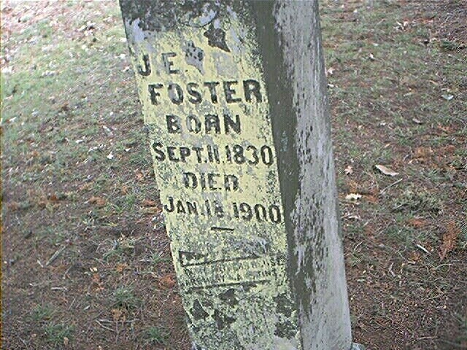

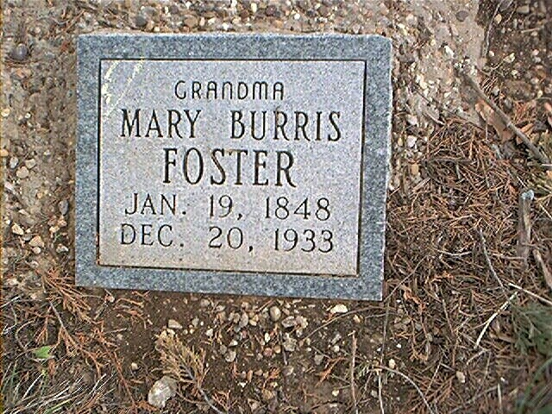
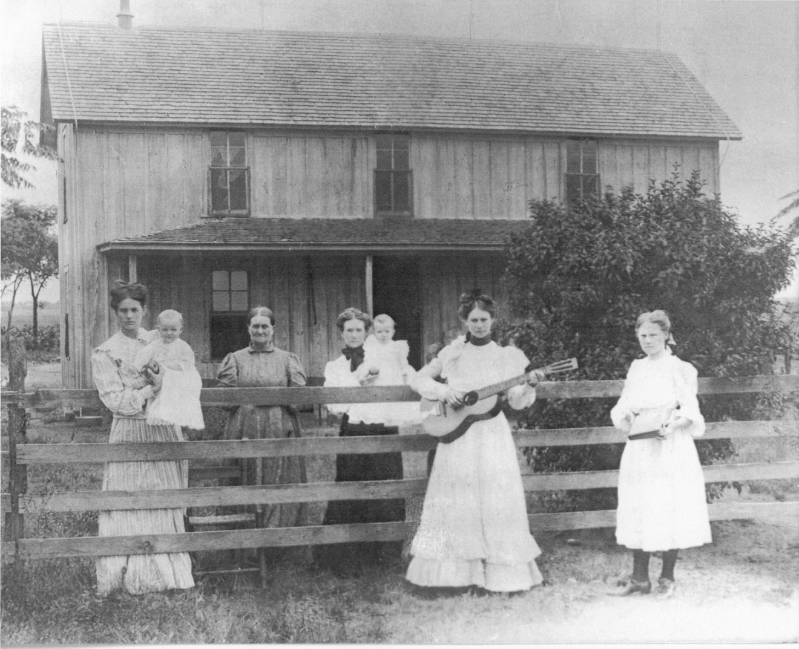

The older lady in the picture, standing before an empty chair, (which denotes she is a widow), is Mary Ann Burris Foster. Holding the guitar is Martha Emsley Foster Wright (my grandmother), and the young girl on the right is Tina Foster Parkhill.
Photo taken in about 1905 in Greenwood, Wise County, Texas
The other women are unidentified.
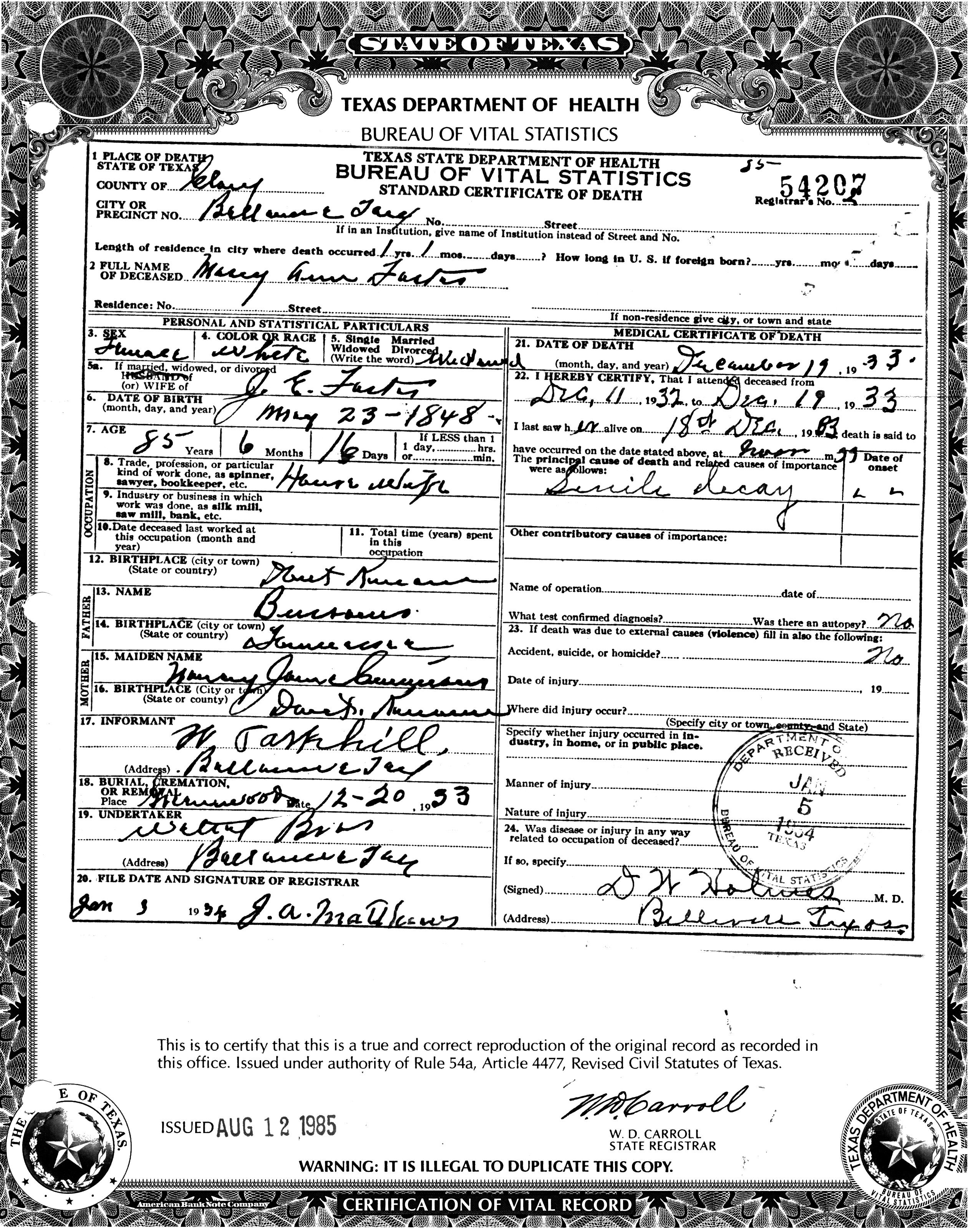

Death Certificate of
Mary Ann Burris Foster
Daughter of Nancy Ann Cunnius
(The cause of death is listed as senile decay which means “old age”)
Descendants of John Jacob Cunnius

Generation No. 1

1. JOHN JACOB¹ CUNNIUS

Child of JOHN JACOB CUNNIUS is:
2. i. JOHANNES² CUNNIUS, b. Feb 17, 1732/33, Dorfe Winterheim, Germany; d. Feb 20, 1808, Reading, Berks Co., PA.

Generation No. 2

2. JOHANNES² CUNNIUS (JOHN JACOB¹) was born Feb 17, 1732/33 in Dorfe Winterheim, Germany, and died Feb 20, 1808 in Reading, Berks Co., PA. He married MARIA ELIZABETH CATHERINE GRIESEMER Jan 24, 1755 in Berks Co., PA, daughter of VALENTINE GRIESEMER. She was born 1736, and died 1816.

Children of JOHANNES CUNNIUS and MARIA GRIESEMER are:
i. WILHELM³ CUNNIUS, b. 1755.
ii. ANNA MARIA CUNNIUS, b. 1759.
iii. JOHAN NICOLAUS CUNNIUS, b. 1759.
iv. ANNA MARGERETHA CUNNIUS, b. 1761.
v. CATHARINE CUNNIUS, b. 1763.
vi. JOHN PHILLIP CUNNIUS, b. 1770.
vii. ELIZABETH CUNNIUS, b. 1772.
3. viii. JOHANNES JACOB CUNNIUS, b. Oct 7, 1765, PA; d. 1863, Madison Co., KY.

Generation No. 3

3. JOHANNES JACOB³ CUNNIUS (JOHANNES², JOHN JACOB¹) was born Oct 7, 1765 in PA, and died 1863 in Madison Co., KY. He married (1) ESTHER YODER May 25, 1790 in Schwartzenwald Reformed Church, Oley, PA, daughter of YOST YODER and MARIA KEIM. She was born 1767. He married (2) MARY PHELPS 1808.

Children of JOHANNES CUNNIUS and ESTHER YODER are:
4. i. TARLTON⁴ CUNNIUS, b. 1801, KY; d. Apr 1870, Wise Co., TX.
ii. JOHN Y. CUNNIUS.
iii. CATHERINE CUNNIUS, m. JAMES LONG, Dec 16, 1818.
iv. WILLIAM CUNNIUS, b. IN.
v. ELIZABETH CUNNIUS, m. UNKNOWN GROOMER.
vi. ARTEMISIA CUNNIUS, m. ANDREW PINKSTON, Oct 30, 1832.
vii. LETTIE CUNNIUS, m. UNKNOWN ROBERTS.
viii. POLLY CUNNIUS, m. JESSE TUDER, Abt. 1822.

Child of JOHANNES CUNNIUS and MARY PHELPS is:
ix. JOHN Y.⁴ CUNNIUS, b. 1790.

Generation No. 4

4. TARLTON⁴ CUNNIUS (JOHANNES JACOB³, JOHANNES², JOHN JACOB¹) was born 1801 in KY, and died Apr 1870 in Wise Co., TX. He married (1) LIVINIA in Prob Collin Co., TX. She was born Abt. 1815 in IL, and died Aft. 1860. He married (2) KATHERINE NICHOLAS May 16, 1822 in Jefferson Co., AL. She died Bef. 1840 in prob Conway Co., AR.

Children of TARLTON CUNNIUS and LIVINIA are:
i. MARTHA⁵ CUNNIUS.
ii. SERIPHINA CUNNIUS, b. Nov 1840; d. 1927.
5. iii. THOMAS ROLAND CUNNIUS, b. Abt. 1843.
6. iv. JANE C CUNNIUS, b. Jan 13, 1843, Conway, AR; d. Oct 29, 1883, Greenwood, Wise Co., TX.
v. BENJAMIN FRANK CUNNIUS, b. 1846, Conway Co., AR; d. 1870, Wise Co., TX; m. ELLEN.
vi. WILLIAM F CUNNIUS, b. 1849.
vii. AMOS T.R. CUNNIUS, b. Abt. 1850.
viii. LARKIN A CUNNIUS, b. Abt. 1853, TX; d. Dec 29, 1925, Holdenville, Hughes Co., OK; m. EBQUONIA COLDASUN, Dec 2, 1882, Wise Co., TX; d. Bef. 1925.
ix. JAMES H CUNNIUS, b. Abt. 1855; d. Abt. 1887, Died in jail awaiting trial for murder.

Children of TARLTON CUNNIUS and KATHERINE NICHOLAS are:
x. MARY⁵ CUNNIUS.
7. xi. NANCY ANN CUNNIUS, b. Nov 1825, AL; d. Aft. 1910, Prob TX.
xii. ABRAHAM CUNNIUS, b. 1835.

Generation No. 5

5. THOMAS ROLAND⁵ CUNNIUS (TARLTON⁴, JOHANNES JACOB³, JOHANNES², JOHN JACOB¹) was born Abt. 1843. He married SARAH MARGARET GAGE Abt. 1874 in Wise Co., TX. She was born 1844, and died 1917 in Wise Co., TX.

Children of THOMAS CUNNIUS and SARAH GAGE are:
i. ROBERT HALL⁶ CUNNIUS, b. 1876.
ii. JERRY L. CUNNIUS, b. 1876.
8. iii. JAMES TARLTON CUNNIUS, b. Oct 23, 1879, Wise Co., TX; d. Apr 13, 1956, Decatur, Wise Co., TX.
iv. ELK CAIN CUNNIUS, b. 1907.

6. JANE C⁵ CUNNIUS (TARLTON⁴, JOHANNES JACOB³, JOHANNES², JOHN JACOB¹) was born Jan 13, 1843 in Conway, AR, and died Oct 29, 1883 in Greenwood, Wise Co., TX. She married SAMUEL MAJOR FOSTER 1859 in Wise Co., TX, son of ALBERT FOSTER and LUCINDA MAJOR. He was born Jan 19, 1834 in Wilson Co., TN, and died Feb 6, 1900 in Greenwood, Wise Co., TX.

Children of JANE CUNNIUS and SAMUEL FOSTER are:
i. LUCY JANE⁶ FOSTER, b. Nov 19, 1860, Wise Co., TX; d. Mar 21, 1886, Wise Co., TX; m. THOMAS GORHAM.
ii. JOHN T FOSTER, b. May 20, 1863, Brumlow Community, Wise Co., TX; d. Dec 8, 1885, Decatur, Wise Co., TX; m. MATTIE MARTHA HILL, Oct 11, 1885, Greenwood, Wise Co., TX.
iii. MARY L FOSTER, b. 1864.
9. iv. WILLIAM F FOSTER, b. May 20, 1865, Wise Co., TX; d. Mar 17, 1901.
v. SAMUEL MAJOR FOSTER JR., b. Jul 8, 1867, Wise Co., TX; d. Nov 24, 1887, Wise Co., TX.
vi. NANCY ANN FOSTER, b. Feb 14, 1869, Wise Co., TX; d. Oct 9, 1892, Wise Co., TX; m. W.M. HERNDON.
vii. JAMES B FOSTER, b. 1870, Wise Co., TX; m. JANE A..
10. viii. GEORGE L FOSTER, b. Feb 14, 1873, Wise Co., TX; d. May 14, 1897, Wise Co., TX.
ix. RUTH B FOSTER, b. 1875.
11. x. WILLIAM "DUB" FOSTER, b. Sep 15, 1876, Greenwood, Wise Co., TX; d. Sep 29, 1949, Bryan, TX.
xi. S M FOSTER, b. 1878.
xii. CHRISTOPHER FOSTER, b. 1880.
7. NANCY ANN⁵ CUNNIUS (TARLTON⁴, JOHANNES JACOB³, JOHANNES², JOHN JACOB¹) was born Nov 1825 in AL, and died Aft. 1910 in Prob TX. She married (1) JONATHAN R. BURRIS 1847 in Grayson Co., TX. He was born 1821 in KY. She married (2) ELLCANA LOLLAR Mar 28, 1854 in Collin Co., TX. He was born 1813 in TN. She married (3) JEREMIAH MONROE GAGE Abt. 1870. He was born 1815 in TN.

Children of NANCY CUNNIUS and JONATHAN BURRIS are:
12. i. MARY ANN⁶ BURRIS, b. Jan 19, 1848, TX; d. Dec 20, 1933, Clay Co., TX.
ii. BENJAMIN T. BURRIS, b. Abt. 1853.

Generation No. 6

8. JAMES TARLTON⁶ CUNNIUS (THOMAS ROLAND⁵, TARLTON⁴, JOHANNES JACOB³, JOHANNES², JOHN JACOB¹) was born Oct 23, 1879 in Wise Co., TX, and died Apr 13, 1956 in Decatur, Wise Co., TX. He married MARY ANNA DEMENT Aug 25, 1907 in Decatur, TX. She was born Mar 2, 1889, and died Sep 5, 1981 in Wise Co., TX.

Children of JAMES CUNNIUS and MARY DEMENT are:
13. i. WILLIE MAE⁷ CUNNIUS, b. Jul 7, 1908, Stoney, Wise Co., TX; d. Apr 14, 2000, Decatur, Wise Co., TX.
ii. GEORGE L. CUNNIUS, b. Feb 22, 1910, Wise Co., TX; d. Feb 22, 1910, Wise Co., TX; m. MAXINE LONGMIRE.
iii. LORINE CUNNIUS, b. 1918.
iv. FLORINE CUNNIUS, b. 1918.

9. WILLIAM F⁶ FOSTER (JANE C⁵ CUNNIUS, TARLTON⁴, JOHANNES JACOB³, JOHANNES², JOHN JACOB¹) was born May 20, 1865 in Wise Co., TX, and died Mar 17, 1901. He married MARY JO SAMPLER Nov 15, 1894 in Wise Co., TX.

Child of WILLIAM FOSTER and MARY SAMPLER is:
i. WILLIE MAE⁷ FOSTER, b. May 28, 1901; d. Nov 4, 1901.

10. GEORGE L⁶ FOSTER (JANE C⁵ CUNNIUS, TARLTON⁴, JOHANNES JACOB³, JOHANNES², JOHN JACOB¹) was born Feb 14, 1873 in Wise Co., TX, and died May 14, 1897 in Wise Co., TX. He married ALICE LAVONIA CAMPBELL Apr 23, 1895 in Wise Co., TX.

Child of GEORGE FOSTER and ALICE CAMPBELL is:
i. RUTH EUTOLIA⁷ FOSTER, b. Mar 26, 1896; d. Jan 25, 1900.

11. WILLIAM "DUB"⁶ FOSTER (JANE C⁵ CUNNIUS, TARLTON⁴, JOHANNES JACOB³, JOHANNES², JOHN JACOB¹) was born Sep 15, 1876 in Greenwood, Wise Co., TX, and died Sep 29, 1949 in Bryan, TX. He married MATTIE ETELLE CAMPBELL Jul 13, 1944 in Plainview, Hale Co., TX. She was born 1877, and died 1944.

Children of WILLIAM FOSTER and MATTIE CAMPBELL are:
i. ZEE⁷ FOSTER, b. Jul 28, 1897.
ii. VIVIAN FOSTER, b. May 28, 1900.
iii. JIM DWAIN FOSTER, b. Jul 28, 1902.
iv. TOMMY EDWIN FOSTER, b. Jun 23, 1905.
v. EVA PEARL FOSTER, b. Aug 27, 1908.
vi. GERALD B "JACK" FOSTER, b. Dec 28, 1909.
vii. BOYD CAMPBELL FOSTER, b. Apr 5, 1912.
viii. W. CARROLL FOSTER.
ix. JAMES LOUIS FOSTER.

12. MARY ANN⁶ BURRIS (NANCY ANN⁵ CUNNIUS, TARLTON⁴, JOHANNES JACOB³, JOHANNES², JOHN JACOB¹) was born Jan 19, 1848 in TX, and died Dec 20, 1933 in Clay Co., TX. She married JOHN EMSLEY FOSTER 1866 in Wise Co., TX, son of ALBERT FOSTER and LUCINDA MAJOR. He was born Sep 11, 1831 in Wilson Co., TN, and died Jan 18, 1900 in Wise Co., TX.

Children of MARY BURRIS and JOHN FOSTER are:
i. ROBERT H.⁷ FOSTER, b. 1867, Sebastian Co., AR.
ii. WILLIAM FOSTER, b. Apr 1870, Sebastian Co., AR; d. Bef. 1880, Wise Co., TX.
iii. THOMAS FOSTER, b. 1871, Wise Co., TX.
iv. S.J. FOSTER, b. Mar 2, 1873, Wise Co., TX; d. Oct 31, 1873, Wise Co., TX.
14. v. JAMES MORRIS FOSTER, b. Jan 1875, Wise Co., TX; d. 1956, Plainview, TX.
vi. ALICE M. FOSTER, b. Jan 1880, Wise Co., TX; d. Prob Portales, NM; m. LACKEY; d. Prob Portales, N.M..
15. vii. MARTHA EMSLEY FOSTER, b. Aug 5, 1882, Wise Co., TX; d. May 15, 1963, Cochran Co., TX.
viii. BENNIE FOSTER, b. Jul 1888, Wise Co., TX.
16. ix. TINA FOSTER, b. Jan 18, 1890, Wise Co., TX; d. Dec 1975, Wichita Falls, TX.

Generation No. 7

13. WILLIE MAE⁷ CUNNIUS (JAMES TARLTON⁶, THOMAS ROLAND⁵, TARLTON⁴, JOHANNES JACOB³, JOHANNES², JOHN JACOB¹) was born Jul 7, 1908 in Stoney, Wise Co., TX, and died Apr 14, 2000 in Decatur, Wise Co., TX. She married WILLIAM LITTLETON FOSTER Sep 29, 1929 in Decatur, TX, son of THOMAS FOSTER and SUE MADDEN. He was born Jan 13, 1903 in Greenwood, Wise Co., TX, and died Mar 12, 1948 in Des Moines, IA.

Child of WILLIE CUNNIUS and WILLIAM FOSTER is:
i. MERRITT⁸ FOSTER.

14. JAMES MORRIS⁷ FOSTER (MARY ANN⁶ BURRIS, NANCY ANN⁵ CUNNIUS, TARLTON⁴, JOHANNES JACOB³, JOHANNES², JOHN JACOB¹) was born Jan 1875 in Wise Co., TX, and died 1956 in Plainview, TX. He married MARY JERUSHA BELL 1905 in Cooke Co., TX.

Children of JAMES FOSTER and MARY BELL are:
i. ALVIN⁸ FOSTER, b. Abt. 1906.
ii. STELLA FOSTER, b. Abt. 1908.
iii. LEMUAL FOSTER, b. Abt. 1910.

15. MARTHA EMSLEY⁷ FOSTER (MARY ANN⁶ BURRIS, NANCY ANN⁵ CUNNIUS, TARLTON⁴, JOHANNES JACOB³, JOHANNES², JOHN JACOB¹) was born Aug 5, 1882 in Wise Co., TX, and died May 15, 1963 in Cochran Co., TX. She married CHARLES EASTON WRIGHT Dec 9, 1906 in Cooke Co., TX, son of NATHAN WRIGHT and MARY MOSLEY. He was born Jan 27, 1881 in Taney Co., MO, and died Mar 9, 1933 in Bowie, TX.

Children of MARTHA FOSTER and CHARLES WRIGHT are:
17. i. JEWELL GLADYS⁸ WRIGHT, b. Oct 11, 1907, Leo, Cooke Co., TX; d. Nov 19, 1996, Morton, TX.
18. ii. FORREST NATHAN WRIGHT, b. Feb 18, 1909, Leo, Cooke Co., TX; d. Jul 2, 1977, Wichita Falls, TX.
iii. JAMES WRIGHT, b. Jan 14, 1911, Lamar, Hughes Co., OK; d. Sep 10, 1994, Wichita Falls, TX.
19. iv. RUBY MARY WRIGHT, b. Dec 24, 1913, Lamar, Hughes Co., OK.
v. BURNEY HULEN WRIGHT, b. Jun 7, 1915, Lamar, Hughes Co., OK.
20. vi. CONNIE LESTER WRIGHT, b. May 20, 1917, Lamar, Hughes Co., OK; d. Jan 2, 2003, Wichita Falls, TX.
21. vii. CHARLES WAIN WRIGHT, b. Mar 26, 1920, Gilliam, Sevier Co., AR; d. Feb 19, 1987, Westhoff, DeWitt, TX.
viii. TINA DISHIELD WRIGHT, b. Dec 27, 1923, Wilbarger Co., TX; d. May 25, 1924, Wilbarger Co., TX.
ix. WILLIAM KENNETH WRIGHT, b. Jun 20, 1925, TX.

16. TINA⁷ FOSTER (MARY ANN⁶ BURRIS, NANCY ANN⁵ CUNNIUS, TARLTON⁴, JOHANNES JACOB³, JOHANNES², JOHN JACOB¹) was born Jan 18, 1890 in Wise Co., TX, and died Dec 1975 in Wichita Falls, TX. She married WALLACE PARKHILL 1907 in Clay Co., TX. He was born Sep 17, 1883 in Clay Co., TX, and died Dec 2, 1946 in Wichita Co., TX.

Children of TINA FOSTER and WALLACE PARKHILL are:
22. i. OLAN DOUGLAS⁸ PARKHILL, b. Jun 14, 1923, Montague Co., TX; d. Jan 17, 1997, Clay Co., TX.
ii. MABEL PARKHILL, b. Mar 1908; d. Aug 31, 1931.
23. iii. LORINE PARKHILL, b. Nov 30, 1913, Montague Co., TX; d. May 18, 2000, Wichita Falls, TX.
24. iv. FAYDEAN PARKHILL, b. Dec 28, 1924, Montague Co., TX; d. Jul 9, 1999, Wichita Falls, TX.
25. v. SYBIL ODELL PARKHILL, b. May 9, 1916; d. Nov 1996, Wichita Co., TX.
vi. WALLACE PARKHILL, b. Jan 21, 1911, Charlie, TX; d. Oct 18, 1985, Wichita Falls, TX; m. BONNIE MARIE SMITH, Apr 18, 1944, Davidson, OK.

Generation No. 8

17. JEWELL GLADYS⁸ WRIGHT (MARTHA EMSLEY⁷ FOSTER, MARY ANN⁶ BURRIS, NANCY ANN⁵ CUNNIUS, TARLTON⁴, JOHANNES JACOB³, JOHANNES², JOHN JACOB¹) was born Oct 11, 1907 in Leo, Cooke Co., TX, and died Nov 19, 1996 in Morton, TX. She married GEORGE OLIVER LYON Sep 15, 1931 in Montague Co., TX, son of GOODRICH LYON and ELVIRA MCGRADY. He was born Mar 23, 1907 in Montague Co., TX, and died May 1996 in Morton, TX.

Children of JEWELL WRIGHT and GEORGE LYON are:
26. i. BONNIE RUTH⁹ LYON, b. Feb 14, 1932, Montague Co., TX.
27. ii. BETTY LOU LYON, b. Apr 24, 1933, Montague Co., TX.
28. iii. EVA LYON, b. Nov 17, 1934, Montague Co., TX.
29. iv. CHARLES ALVIN LYON, b. Jul 1, 1936, Montague Co., TX; d. 1957, Seminole, TX.
30. v. GOODRICH WAYNE LYON, b. Feb 22, 1938, Montague Co., TX.
31. vi. WILMA JEAN LYON, b. Nov 19, 1942, Lubbock, TX; d. Jun 7, 1997, Wolforth, TX.
32. vii. EDDY LYNN LYON, b. Jan 11, 1948, Levelland, TX.
viii. SANDRA LYON, b. Jan 16, 1951, Levelland, TX; m. BENNIE TORRES, Apr 14, 1981, Levelland, TX.

18. FORREST NATHAN⁸ WRIGHT (MARTHA EMSLEY⁷ FOSTER, MARY ANN⁶ BURRIS, NANCY ANN⁵ CUNNIUS, TARLTON⁴, JOHANNES JACOB³, JOHANNES², JOHN JACOB¹) was born Feb 18, 1909 in Leo, Cooke Co., TX, and died Jul 2, 1977 in Wichita Falls, TX. He married (1) ETHELENE GAINES Nov 24, 1936 in Frederick, OK, daughter of ERNEST GAINES and LOUELLA BAGGETT. She was born Jan 10, 1919 in Electra, Wichita Co., TX. He married (2) LUCY RECK SEFCIK Jan 8, 1973 in Archer City, TX. She was born Sep 5, 1918 in Wilbarger Co, TX, and died Jul 16, 1996 in Electra, Wichita Co., TX.

Children of FORREST WRIGHT and ETHELENE GAINES are:
33. i. GARY FORREST⁹ WRIGHT, b. Sep 11, 1937, Electra, TX.
34. ii. EARNEST LYNN WRIGHT, b. Oct 19, 1939, Electra, Wichita Co., TX.
35. iii. MICHAEL CORBETT WRIGHT, b. Jun 26, 1944, Wichita Falls, TX.
36. iv. JUDY LUJEAN WRIGHT, b. Feb 11, 1947, Wichita Falls, TX; d. Sep 11, 1996, Wichita Falls, TX.

19. RUBY MARY⁸ WRIGHT (MARTHA EMSLEY⁷ FOSTER, MARY ANN⁶ BURRIS, NANCY ANN⁵ CUNNIUS, TARLTON⁴, JOHANNES JACOB³, JOHANNES², JOHN JACOB¹) was born Dec 24, 1913 in Lamar, Hughes Co., OK. She married TROY H. SLADE Dec 24, 1930 in Waurika, OK. He was born Dec 30, 1914 in Montague Co., TX, and died Mar 5, 1996 in Montague Co., TX.

Children of RUBY WRIGHT and TROY SLADE are:
i. LOIS MARIE⁹ SLADE, b. Nov 2, 1931, Montague Co., TX; m. WILLIAM PHILLIPS.
ii. GLADYS SLADE, b. Oct 3, 1935, Montague Co., TX; m. ARCUE DEWEBER.
iii. LLOYD SLADE, b. Aug 30, 1943, Montague Co., TX; m. JANE HARPER.
iv. LINDA SLADE, b. Jan 10, 1951, Montague Co., TX; m. RONNIE MCCLINTOCK.

20. CONNIE LESTER⁸ WRIGHT (MARTHA EMSLEY⁷ FOSTER, MARY ANN⁶ BURRIS, NANCY ANN⁵ CUNNIUS, TARLTON⁴, JOHANNES JACOB³, JOHANNES², JOHN JACOB¹) was born May 20, 1917 in Lamar, Hughes Co., OK, and died Jan 2, 2003 in Wichita Falls, TX. He married LOU ELLA GOODWIN Feb 28, 1942 in Wichita Falls, TX. She was born Aug 27, 1923 in Hunt Co., TX.

Children of CONNIE WRIGHT and LOU GOODWIN are:
i. LESTER EARL⁹ WRIGHT, b. Sep 1, 1944, Electra, TX; m. (1) PAULA JO VACARI, May 1965; m. (2) SHARON WALLACE, Mar 1975, Wichita Falls, TX.
ii. STELLA LOUISE WRIGHT, b. Feb 9, 1949; m. (1) GLEN CALVIN CHITWOOD, Apr 1967, Burkburnett, TX; m. (2) ROBERT TILDEN COTTON, Nov 1, 1973, Wichita Falls, TX.
iii. CONNIE LUCILLE WRIGHT, b. Nov 12, 1957; m. GARY MICHAEL STEWART, Feb 28, 1981, Wichita Falls, TX.

21. CHARLES WAIN⁸ WRIGHT (MARTHA EMSLEY⁷ FOSTER, MARY ANN⁶ BURRIS, NANCY ANN⁵ CUNNIUS, TARLTON⁴, JOHANNES JACOB³, JOHANNES², JOHN JACOB¹) was born Mar 26, 1920 in Gilliam, Sevier Co., AR, and died Feb 19, 1987 in Westhoff, DeWitt, TX. He married (1) SADIE. He married (2) BETTY JEAN RUSSELL Jan 26, 1953 in Corpus Christi, TX.

Children of CHARLES WRIGHT and SADIE are:
i. JAMES⁹ WRIGHT.
ii. KENNETH WRIGHT.

Children of CHARLES WRIGHT and BETTY RUSSELL are:
iii. DENNIS WAYNE⁹ WRIGHT, b. Mar 9, 1954.
iv. DONALD DEWAYNE WRIGHT, b. Oct 13, 1955.
v. JEAN ANN WRIGHT, b. Jul 31, 1957.
vi. GARY WAYNE WRIGHT, b. Sep 7, 1959.
vii. WAYNE CHARLIE WRIGHT JR., b. Feb 9, 1966.

22. OLAN DOUGLAS⁸ PARKHILL (TINA⁷ FOSTER, MARY ANN⁶ BURRIS, NANCY ANN⁵ CUNNIUS, TARLTON⁴, JOHANNES JACOB³, JOHANNES², JOHN JACOB¹) was born Jun 14, 1923 in Montague Co., TX, and died Jan 17, 1997 in Clay Co., TX. He married BETTY JO STEWART Jan 17, 1947 in Clay Co., TX, daughter of JOHN STEWART and BELLE HARMON. She was born Jan 5, 1928 in Wichita Co., TX.

Children of OLAN PARKHILL and BETTY STEWART are:
37. i. ROBERT OLAN⁹ PARKHILL, b. Apr 19, 1948, Wichita Co., TX.
38. ii. NELDA JO PARKHILL, b. Jul 27, 1951, Wichita Co., TX.
39. iii. TINA MARIE PARKHILL, b. Mar 3, 1953, Wichita Co., TX.

23. LORINE⁸ PARKHILL (TINA⁷ FOSTER, MARY ANN⁶ BURRIS, NANCY ANN⁵ CUNNIUS, TARLTON⁴, JOHANNES JACOB³, JOHANNES², JOHN JACOB¹) was born Nov 30, 1913 in Montague Co., TX, and died May 18, 2000 in Wichita Falls, TX. She married (1) ALTON PARKER. He died 1981. She married (2) JOE FOSTER.

Children of LORINE PARKHILL and ALTON PARKER are:
40. i. VELTON R.⁹ PARKER, b. Jun 15, 1933; d. Feb 19, 1984.
41. ii. CHARLES BUDDY PARKER, b. Jun 13, 1941.

24. FAYDEAN⁸ PARKHILL (TINA⁷ FOSTER, MARY ANN⁶ BURRIS, NANCY ANN⁵ CUNNIUS, TARLTON⁴, JOHANNES JACOB³, JOHANNES², JOHN JACOB¹) was born Dec 28, 1924 in Montague Co., TX, and died Jul 9, 1999 in Wichita Falls, TX. She married MORMAN PATTERSON, son of H.M. PATTERSON and LEONA VAUGHN. He was born Sep 2, 1922 in Rockwall, TX.

Children of FAYDEAN PARKHILL and MORMAN PATTERSON are:
i. BABY GIRL⁹ ADOPTED, b. Abt. 1943, Orphans Home, Ft Worth, TX.
42. ii. LETRICIA A. PATTERSON, b. Nov 11, 1945.
43. iii. PATTY SUE PATTERSON, b. Sep 30, 1947.

25. SYBIL ODELL⁸ PARKHILL (TINA⁷ FOSTER, MARY ANN⁶ BURRIS, NANCY ANN⁵ CUNNIUS, TARLTON⁴, JOHANNES JACOB³, JOHANNES², JOHN JACOB¹) was born May 9, 1916, and died Nov 1996 in Wichita Co., TX. She married CLIFFORD ROLAND. He was born Jul 16, 1906, and died Jun 5, 1988.

Child of SYBIL PARKHILL and CLIFFORD ROLAND is:
44. i. JOE DON⁹ ROLAND, b. Apr 1, 1943; d. Jul 23, 1989.

Generation No. 9

26. BONNIE RUTH⁹ LYON (JEWELL GLADYS⁸ WRIGHT, MARTHA EMSLEY⁷ FOSTER, MARY ANN⁶ BURRIS, NANCY ANN⁵ CUNNIUS, TARLTON⁴, JOHANNES JACOB³, JOHANNES², JOHN JACOB¹) was born Feb 14, 1932 in Montague Co., TX. She married BURL THOMAS MCDOWRA Jul 26, 1951 in Fort Sumner, NM. He was born Mar 8, 1931 in Levelland, TX, and died Nov 13, 1982 in Ozona, TX.

Children of BONNIE LYON and BURL MCDOWRA are:
i. JUDY LYNETTE¹⁰ MCDOWRA, b. May 31, 1952; m. (1) DANNY PIGG, Borger, TX; m. (2) HERBERT ZIELONKA; d. 2002, Cuero, TX.
ii. DEBRA JEAN MCDOWRA, b. Jul 22, 1953.
iii. KENNETH EARL MCDOWRA, b. Apr 19, 1956.
iv. VICKI LEA MCDOWRA, b. Sep 14, 1962.
v. MICHAEL DAVID MCDOWRA, b. Nov 4, 1966, Levelland, TX; d. Nov 4, 1966, Levelland, TX.

27. BETTY LOU⁹ LYON (JEWELL GLADYS⁸ WRIGHT, MARTHA EMSLEY⁷ FOSTER, MARY ANN⁶ BURRIS, NANCY ANN⁵ CUNNIUS, TARLTON⁴, JOHANNES JACOB³, JOHANNES², JOHN JACOB¹) was born Apr 24, 1933 in Montague Co., TX. She married RAYFORD WHISENHUNT Jul 5, 1950 in Lovington, NM.

Child of BETTY LYON and RAYFORD WHISENHUNT is:
i. DANNY¹⁰ WHISENHUNT.

28. EVA⁹ LYON (JEWELL GLADYS⁸ WRIGHT, MARTHA EMSLEY⁷ FOSTER, MARY ANN⁶ BURRIS, NANCY ANN⁵ CUNNIUS, TARLTON⁴, JOHANNES JACOB³, JOHANNES², JOHN JACOB¹) was born Nov 17, 1934 in Montague Co., TX. She married JOHNNY PLUNKETT May 1955 in Mineral Wells, TX.

Children of EVA LYON and JOHNNY PLUNKETT are:
i. CINTHIA¹⁰ PLUNKETT.
ii. JAY PLUNKETT.

29. CHARLES ALVIN⁹ LYON (JEWELL GLADYS⁸ WRIGHT, MARTHA EMSLEY⁷ FOSTER, MARY ANN⁶ BURRIS, NANCY ANN⁵ CUNNIUS, TARLTON⁴, JOHANNES JACOB³, JOHANNES², JOHN JACOB¹) was born Jul 1, 1936 in Montague Co., TX, and died 1957 in Seminole, TX. He married NORMA COX Jul 6, 1954 in Lovington, NM.

Children of CHARLES LYON and NORMA COX are:
i. MICHAEL CHARLES¹⁰ LYON.
ii. SUSAN LYON.

30. GOODRICH WAYNE⁹ LYON (JEWELL GLADYS⁸ WRIGHT, MARTHA EMSLEY⁷ FOSTER, MARY ANN⁶ BURRIS, NANCY ANN⁵ CUNNIUS, TARLTON⁴, JOHANNES JACOB³, JOHANNES², JOHN JACOB¹) was born Feb 22, 1938 in Montague Co., TX. He married BETTY KUEHLER Feb 14, 1963 in Morton, TX.

Children of GOODRICH LYON and BETTY KUEHLER are:
i. GLEN¹⁰ LYON.
ii. GARY LYON.
iii. KIM LYON.
iv. JULIE LYON.

31. WILMA JEAN⁹ LYON (JEWELL GLADYS⁸ WRIGHT, MARTHA EMSLEY⁷ FOSTER, MARY ANN⁶ BURRIS, NANCY ANN⁵ CUNNIUS, TARLTON⁴, JOHANNES JACOB³, JOHANNES², JOHN JACOB¹) was born Nov 19, 1942 in Lubbock, TX, and died Jun 7, 1997 in Wolforth, TX. She married JAMES JACKSON Dec 15, 1968 in Lubbock, TX.

Children of WILMA LYON and JAMES JACKSON are:
i. WILLIAM¹⁰ JACKSON.
ii. JAMES JACKSON JR..
iii. BRENDA JACKSON.

32. EDDY LYNN⁹ LYON (JEWELL GLADYS⁸ WRIGHT, MARTHA EMSLEY⁷ FOSTER, MARY ANN⁶ BURRIS, NANCY ANN⁵ CUNNIUS, TARLTON⁴, JOHANNES JACOB³, JOHANNES², JOHN JACOB¹) was born Jan 11, 1948 in Levelland, TX. He married CATHY BARNETT Mar 15, 1978 in Lubbock, TX.

Child of EDDY LYON and CATHY BARNETT is:
i. TYSON¹⁰ LYON.

33. GARY FORREST⁹ WRIGHT (FORREST NATHAN⁸, MARTHA EMSLEY⁷ FOSTER, MARY ANN⁶ BURRIS, NANCY ANN⁵ CUNNIUS, TARLTON⁴, JOHANNES JACOB³, JOHANNES², JOHN JACOB¹) was born Sep 11, 1937 in Electra, TX. He married JESSIE LEE MARTIN Feb 29, 1964 in Henrietta, Clay Co., TX, daughter of N.F. MARTIN and ZELLA STOUT. She was born Mar 23, 1931 in Wichita Falls, TX, and died Feb 13, 2004 in Dallas, TX.

Children of GARY WRIGHT and JESSIE MARTIN are:
i. KELLY FORREST¹⁰ WRIGHT, b. May 28, 1965, Iowa Park, TX.
ii. CHRISTOPHER LEE WRIGHT, b. Oct 22, 1969, Iowa Park, TX.

34. EARNEST LYNN⁹ WRIGHT (FORREST NATHAN⁸, MARTHA EMSLEY⁷ FOSTER, MARY ANN⁶ BURRIS, NANCY ANN⁵ CUNNIUS, TARLTON⁴, JOHANNES JACOB³, JOHANNES², JOHN JACOB¹) was born Oct 19, 1939 in Electra, Wichita Co., TX. He married (1) CHARLOTTE ELENA RANDALL Sep 1, 1962 in East Machias, ME, daughter of CLARENCE RANDALL and SHIRLEY WILCOX. She was born Mar 21, 1944 in Machias, Washington Co., ME. He married (2) PATRICIA MORELL MILLER Jul 21, 1978 in Waltham, MA, daughter of WALTER MOREL and ELEANOR KUDNICK. She was born Mar 2, 1946 in New York City, NY.

Child of EARNEST WRIGHT and CHARLOTTE RANDALL is:
i. JODY LYNNE¹⁰ WRIGHT, b. Sep 5, 1965, Honolulu, HI.

35. MICHAEL CORBETT⁹ WRIGHT (FORREST NATHAN⁸, MARTHA EMSLEY⁷ FOSTER, MARY ANN⁶ BURRIS, NANCY ANN⁵ CUNNIUS, TARLTON⁴, JOHANNES JACOB³, JOHANNES², JOHN JACOB¹) was born Jun 26, 1944 in Wichita Falls, TX. He married MARY ELLEN LAW Jul 17, 1965 in Providence, RI. She was born Feb 10, 1947 in Providence, RI.

Child of MICHAEL WRIGHT and MARY LAW is:
i. NANCY ANNE¹⁰ WRIGHT, b. Jul 1, 1966, Dallas, TX.

36. JUDY LUJEAN⁹ WRIGHT (FORREST NATHAN⁸, MARTHA EMSLEY⁷ FOSTER, MARY ANN⁶ BURRIS, NANCY ANN⁵ CUNNIUS, TARLTON⁴, JOHANNES JACOB³, JOHANNES², JOHN JACOB¹) was born Feb 11, 1947 in Wichita Falls, TX, and died Sep 11, 1996 in Wichita Falls, TX. She married (1) RONNIE CLAUD BOREN 1964 in Wichita Falls, TX. He was born 1943 in Wichita Co., TX. She married (2) JERRY DAN ALLEN Mar 12, 1971 in Wichita Falls, TX. He was born Jan 17, 1947 in Wichita Falls, TX.

Child of JUDY WRIGHT and RONNIE BOREN is:
45. i. MARISA CAROL¹⁰ BOREN, b. Jan 12, 1965, Wichita Falls, TX.

37. ROBERT OLAN⁹ PARKHILL (OLAN DOUGLAS⁸, TINA⁷ FOSTER, MARY ANN⁶ BURRIS, NANCY ANN⁵ CUNNIUS, TARLTON⁴, JOHANNES JACOB³, JOHANNES², JOHN JACOB¹) was born Apr 19, 1948 in Wichita Co., TX. He married WILMA SUE DYER, daughter of HARBART DYER and JAUNITA.

Child of ROBERT PARKHILL and WILMA DYER is:
i. KEVIN ROBERT¹⁰ PARKHILL, b. Mar 25, 1977.

38. NELDA JO⁹ PARKHILL (OLAN DOUGLAS⁸, TINA⁷ FOSTER, MARY ANN⁶ BURRIS, NANCY ANN⁵ CUNNIUS, TARLTON⁴, JOHANNES JACOB³, JOHANNES², JOHN JACOB¹) was born Jul 27, 1951 in Wichita Co., TX. She married HARVEY DAVID MCKEE May 21, 1969 in Wichita Co., TX, son of GEORGE MCKEE and EULA RAY. He was born Nov 28, 1948.

Children of NELDA PARKHILL and HARVEY MCKEE are:
46. i. MISTY MICHEL¹⁰ MCKEE, b. Feb 28, 1970, Comanche Co., OK.
47. ii. CHRISTOPHER DAVID MCKEE, b. Jul 2, 1974, Choctaw Co., OK.
iii. PATRICIA JANE MCKEE, b. Sep 13, 1982, Latimer Co., OK.

39. TINA MARIE⁹ PARKHILL (OLAN DOUGLAS⁸, TINA⁷ FOSTER, MARY ANN⁶ BURRIS, NANCY ANN⁵ CUNNIUS, TARLTON⁴, JOHANNES JACOB³, JOHANNES², JOHN JACOB¹) was born Mar 3, 1953 in Wichita Co., TX. She married LUIS BAUTISTA RAMIREZ Jul 2, 1988 in Henrietta, TX, son of FRANCISCO RAMIREZ and BALVINA BAUTISTA. He was born Sep 26, 1961 in Tasquillo, Mexico.

Children of TINA PARKHILL and LUIS RAMIREZ are:
48. i. STORMI JO¹⁰ PARKHILL, b. Oct 4, 1977, Healdton, Carter Co., OK.
ii. JASON SAMEUL PARKHILL, b. Jul 27, 1987, Stephenville, TX.

40. VELTON R.⁹ PARKER (LORINE⁸ PARKHILL, TINA⁷ FOSTER, MARY ANN⁶ BURRIS, NANCY ANN⁵ CUNNIUS, TARLTON⁴, JOHANNES JACOB³, JOHANNES², JOHN JACOB¹) was born Jun 15, 1933, and died Feb 19, 1984. He married BETTY JONES May 1955. She was born Aug 27, 1938.

Children of VELTON PARKER and BETTY JONES are:
49. i. SANDRA KAY¹⁰ PARKER, b. Dec 17, 1956.
50. ii. MICHAEL WAYNE PARKER, b. Nov 26, 1964.
51. iii. MARK DOUGLAS PARKER, b. Aug 30, 1967.

41. CHARLES BUDDY⁹ PARKER (LORINE⁸ PARKHILL, TINA⁷ FOSTER, MARY ANN⁶ BURRIS, NANCY ANN⁵ CUNNIUS, TARLTON⁴, JOHANNES JACOB³, JOHANNES², JOHN JACOB¹) was born Jun 13, 1941. He married CAROL CAMPBELL. She was born Dec 11, 1943.

Children of CHARLES PARKER and CAROL CAMPBELL are:
52. i. CYNTHIA CAROL¹⁰ PARKER, b. Aug 3, 1964.
53. ii. JAMIE PARKER, b. Feb 1, 1974.

42. LETRICIA A.⁹ PATTERSON (FAYDEAN⁸ PARKHILL, TINA⁷ FOSTER, MARY ANN⁶ BURRIS, NANCY ANN⁵ CUNNIUS, TARLTON⁴, JOHANNES JACOB³, JOHANNES², JOHN JACOB¹) was born Nov 11, 1945. She married (1) HUGH LYNN KUYKENDALL. She married (2) UNKNOWN HOWE.

Children of LETRICIA PATTERSON and HUGH KUYKENDALL are:
54. i. GARY¹⁰ KUYKENDALL, b. Nov 7, 1966, Peran AFB, Grayson Co., TX.
55. ii. DENNA FAY KUYKENDALL, b. Jul 21, 1966, Wichita Co., TX.

43. PATTY SUE⁹ PATTERSON (FAYDEAN⁸ PARKHILL, TINA⁷ FOSTER, MARY ANN⁶ BURRIS, NANCY ANN⁵ CUNNIUS, TARLTON⁴, JOHANNES JACOB³, JOHANNES², JOHN JACOB¹) was born Sep 30, 1947. She married UNKNOWN DODD Jul 27, 1979 in Las Vegas, NV.

Children of PATTY PATTERSON and UNKNOWN DODD are:
56. i. LAURA ANN¹⁰ DODD, b. Jul 23, 1971.
ii. JEFFREY SCOTT DODD, b. May 21, 1973.

44. JOE DON⁹ ROLAND (SYBIL ODELL⁸ PARKHILL, TINA⁷ FOSTER, MARY ANN⁶ BURRIS, NANCY ANN⁵ CUNNIUS, TARLTON⁴, JOHANNES JACOB³, JOHANNES², JOHN JACOB¹) was born Apr 1, 1943, and died Jul 23, 1989. He married (1) BONNIE. He married (2) LAURA JANICE HICKS Jul 18, 1964. She was born Nov 2, 1944.

Child of JOE ROLAND and BONNIE is:
i. SCOOTER¹⁰ ROLAND.

Children of JOE ROLAND and LAURA HICKS are:
ii. TIMMY DON¹⁰ ROLAND.
iii. CANDACE LYNN ROLAND, b. Mar 28, 1973.

Generation No. 10

45. MARISA CAROL¹⁰ BOREN (JUDY LUJEAN⁹ WRIGHT, FORREST NATHAN⁸, MARTHA EMSLEY⁷ FOSTER, MARY ANN⁶ BURRIS, NANCY ANN⁵ CUNNIUS, TARLTON⁴, JOHANNES JACOB³, JOHANNES², JOHN JACOB¹) was born Jan 12, 1965 in Wichita Falls, TX. She married (1) ROBERT WESSEL 1985 in Wichita Falls, TX. He was born in TX. She married (2) BRUCE BALLARD 1995 in TX.

Children of MARISA BOREN and ROBERT WESSEL are:
i. HAYLEY CASSANDRA¹¹ WESSEL, b. Aug 24, 1985.
ii. MEGAN DAWN WESSEL, b. Jan 11, 1991.

46. MISTY MICHEL¹⁰ MCKEE (NELDA JO⁹ PARKHILL, OLAN DOUGLAS⁸, TINA⁷ FOSTER, MARY ANN⁶ BURRIS, NANCY ANN⁵ CUNNIUS, TARLTON⁴, JOHANNES JACOB³, JOHANNES², JOHN JACOB¹) was born Feb 28, 1970 in Comanche Co., OK. She married ENRIQUE MARTINEZ Oct 1988 in Jefferson Co., OK, son of FRANCISCO MARTINEZ and VIRGINIA OLQUIN. He was born Jul 7, 1967 in Mexico.

Children of MISTY MCKEE and ENRIQUE MARTINEZ are:
i. RIQUE JOE¹¹ MARTINEZ, b. Sep 17, 1990, Jefferson Co., OK.
ii. ALEX DOUGLAS MARTINEZ, b. Apr 11, 1995, Comanche Co., OK.

47. CHRISTOPHER DAVID¹⁰ MCKEE (NELDA JO⁹ PARKHILL, OLAN DOUGLAS⁸, TINA⁷ FOSTER, MARY ANN⁶ BURRIS, NANCY ANN⁵ CUNNIUS, TARLTON⁴, JOHANNES JACOB³, JOHANNES², JOHN JACOB¹) was born Jul 2, 1974 in Choctaw Co., OK. He married DAWN MICHELLE ROAN Oct 10, 1991. She was born Nov 23, 1973.

Children of CHRISTOPHER MCKEE and DAWN ROAN are:
i. MIA MICHELLE¹¹ MCKEE, b. May 11, 1992, Jefferson Co., OK.
ii. TANNER DAVID MCKEE, b. Oct 27, 1994, Latimer Co., OK.
iii. TYNA MCKEE, b. Jul 17, 1996, Latimer Co., OK.
iv. HARLEY CHEYENNE MCKEE, b. Jul 1, 1999, Latimer Co., OK.

48. STORMI JO¹⁰ PARKHILL (TINA MARIE⁹, OLAN DOUGLAS⁸, TINA⁷ FOSTER, MARY ANN⁶ BURRIS, NANCY ANN⁵ CUNNIUS, TARLTON⁴, JOHANNES JACOB³, JOHANNES², JOHN JACOB¹) was born Oct 4, 1977 in Healdton, Carter Co., OK. She married (1) BRENT THOMAS GAINES Oct 28, 1995 in Bowie, Montague Co., TX. She married (2) JOSEPH WAYNE KENNEDY May 15, 2000 in Henrietta, TX.

Children of STORMI PARKHILL and BRENT GAINES are:
i. STETSON RAY¹¹ GAINES, b. Jul 18, 1996.
ii. SANTANA GAUGE PARKHILL, b. Jan 21, 1999.
iii. SKYLER BLADE PARKHILL, b. Jan 13, 2000.

49. SANDRA KAY¹⁰ PARKER (VELTON R.⁹, LORINE⁸ PARKHILL, TINA⁷ FOSTER, MARY ANN⁶ BURRIS, NANCY ANN⁵ CUNNIUS, TARLTON⁴, JOHANNES JACOB³, JOHANNES², JOHN JACOB¹) was born Dec 17, 1956. She married JOE BLAIR. He was born 1958.

Children of SANDRA PARKER and JOE BLAIR are:
i. CHRIS SHELTON¹¹ BLAIR, b. Jun 27, 1979.
ii. KELLY JOE BILLS BLAIR, b. Dec 12, 1989.

50. MICHAEL WAYNE¹⁰ PARKER (VELTON R.⁹, LORINE⁸ PARKHILL, TINA⁷ FOSTER, MARY ANN⁶ BURRIS, NANCY ANN⁵ CUNNIUS, TARLTON⁴, JOHANNES JACOB³, JOHANNES², JOHN JACOB¹) was born Nov 26, 1964. He married RHONDA CARLTON Apr 13, 1985. She was born Jul 4, 1965.

Children of MICHAEL PARKER and RHONDA CARLTON are:
i. MITCHELL¹¹ PARKER, b. Jan 13, 1991.
ii. SONNY MASON PARKER, b. Aug 16, 1996.

51. MARK DOUGLAS¹⁰ PARKER (VELTON R.⁹, LORINE⁸ PARKHILL, TINA⁷ FOSTER, MARY ANN⁶ BURRIS, NANCY ANN⁵ CUNNIUS, TARLTON⁴, JOHANNES JACOB³, JOHANNES², JOHN JACOB¹) was born Aug 30, 1967. He married LILLIAN. She was born Mar 5, 1968.

Child of MARK PARKER and LILLIAN is:
i. VELTON SHAWN¹¹ PARKER, b. Jan 18, 2000.

52. CYNTHIA CAROL¹⁰ PARKER (CHARLES BUDDY⁹, LORINE⁸ PARKHILL, TINA⁷ FOSTER, MARY ANN⁶ BURRIS, NANCY ANN⁵ CUNNIUS, TARLTON⁴, JOHANNES JACOB³, JOHANNES², JOHN JACOB¹) was born Aug 3, 1964. She married MORRIS RAY DAVIS. He was born Sep 2, 1964.

Children of CYNTHIA PARKER and MORRIS DAVIS are:
i. JOSHUA RAY¹¹ DAVIS, b. Jan 18, 1991.
ii. CHARLES AARON DAVIS, b. Jun 17, 1993.

53. JAMIE¹⁰ PARKER (CHARLES BUDDY⁹, LORINE⁸ PARKHILL, TINA⁷ FOSTER, MARY ANN⁶ BURRIS, NANCY ANN⁵ CUNNIUS, TARLTON⁴, JOHANNES JACOB³, JOHANNES², JOHN JACOB¹) was born Feb 1, 1974. She married LONNIE DEAN BRUMLEY. He was born Aug 9, 1973.

Children of JAMIE PARKER and LONNIE BRUMLEY are:
i. BRITNEY LYNN¹¹ BRUMLEY, b. Apr 1, 1997.
ii. KELSEY PARKER BRUMLEY, b. Aug 3, 1999.

54. GARY¹⁰ KUYKENDALL (LETRICIA A.⁹ PATTERSON, FAYDEAN⁸ PARKHILL, TINA⁷ FOSTER, MARY ANN⁶ BURRIS, NANCY ANN⁵ CUNNIUS, TARLTON⁴, JOHANNES JACOB³, JOHANNES², JOHN JACOB¹) was born Nov 7, 1966 in Peran AFB, Grayson Co., TX. He married LORI ANN WALKER.

Children of GARY KUYKENDALL and LORI WALKER are:
i. SHELBI NICOLE¹¹ KUYKENDALL, b. Mar 3, 1992, Wichita Falls, TX.
ii. JESSICA LINN KUYKENDALL, b. Sep 12, 1995, Wichita Falls, TX.

55. DENNA FAY¹⁰ KUYKENDALL (LETRICIA A.⁹ PATTERSON, FAYDEAN⁸ PARKHILL, TINA⁷ FOSTER, MARY ANN⁶ BURRIS, NANCY ANN⁵ CUNNIUS, TARLTON⁴, JOHANNES JACOB³, JOHANNES², JOHN JACOB¹) was born Jul 21, 1966 in Wichita Co., TX. She married ANTHONY OTTO.

Children of DENNA KUYKENDALL and ANTHONY OTTO are:
i. DALTON WAYDE¹¹ OTTO, b. Nov 15, 1992, Wichita Co., TX.
ii. ZACHARY SCOTT OTTO, b. Jan 14, 1997, Wichita Co., TX.

56. LAURA ANN¹⁰ DODD (PATTY SUE⁹ PATTERSON, FAYDEAN⁸ PARKHILL, TINA⁷ FOSTER, MARY ANN⁶ BURRIS, NANCY ANN⁵ CUNNIUS, TARLTON⁴, JOHANNES JACOB³, JOHANNES², JOHN JACOB¹) was born Jul 23, 1971.

Child of LAURA ANN DODD is:
i. ABBY LAUREN¹¹ DODD, b. Jun 15, 2000, Wichita Falls, TX.

