Oaklawn Cemetery

Section 9 Blocks 12 & 18

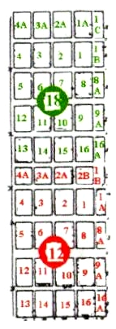
Pasture on East Side
To North Entry Gate

