Oaklawn Cemetery

Section 8

Blocks 13 & 17

To North Entry Gate

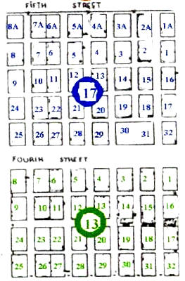
Walnut Street
Pecan Street

