Oaklawn Cemetery

Section 6 Blocks 4 & 5

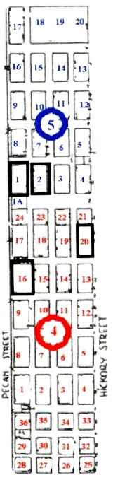
Pasture on East Side

