Oaklawn Cemetery

Section 4

Blocks 1N, 2N, 9 & 10

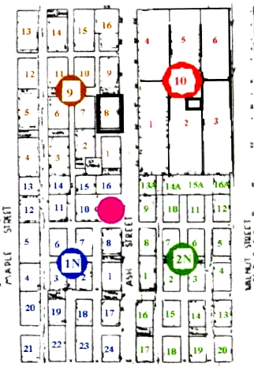

Brick
Gazebo

Fence is actually around north part of Lot 1
No
Fence

