Oaklawn Cemetery

Sections 1 & 2

Block and Lot Map

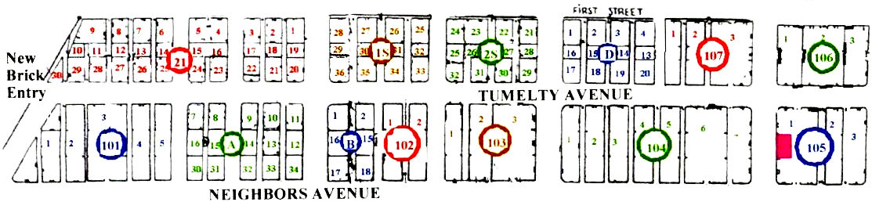

Gazebo

